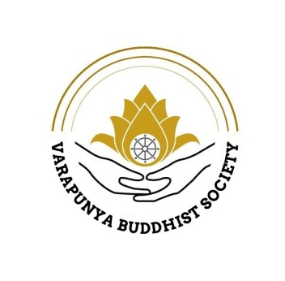


BACK AGAIN, FREE and ‘IN PERSON’, FACE-TO-FACE
MINDFUL LIVING & MINDFULNESS MEDITATION MONDAYS JANUARY TO NOVEMBER 2026
Mindfulness Mondays have restarted face-to-face at Aberdeen Health Village. Discover for yourself how to calm that ‘over-thinking’ mind, cope with everyday anxiety & stress, become a different ‘you’.
When? – the last Monday of each month, join one or both sessions.
Session1: 12.00 noon to 12.50pm
Session 2: 1.00pm to 1.50pm
Dates and Venues:
Monday 26th January 2026 in Learning Room 1, Aberdeen Health Village & Monday 23rd February, 30th March, 27th April, 25th May, 29th June, 27th July, 31st August, 28th September, 26th October & 30th November 2026 in Learning Room 4, Aberdeen Health Village
With whom: Ven. Ajahn Sujan, an experienced Buddhist monk from Nepal & others from the Varapunya Meditation Centre.
Everyone welcome but booking is still essential so we can comply with whatever COVID rules apply at that time.
Please confirm your attendance each month by emailing:
graham.fleming@nhs.scot
For further information contact
https://www.varapunyacentre.com/mindfulness-monday

