**Stakeholder Analysis Template**A stakeholder analysis is a process of identifying stakeholders (people or groups) before the project begins, and grouping them according to their levels of participation, interest, and influence in the project.

|  |  |
| --- | --- |
| **High Power / Interested People – Work together**  Manage Closely – keep fully engaged and fully satisfied with information | **Low Power / Interested People**  Keep Informed and Involved – Keep adequately informed and engaged to prevent issues arising. This group can be helpful with detail of the project. |
| **High Power / Less Interested People**  Keep Satisfied – Keep satisfied with information, but not so much they become bored with the message | **Low Power / Less Interested People**  Keep Monitored - Monitor for further interest, but not bored with excessive communication |

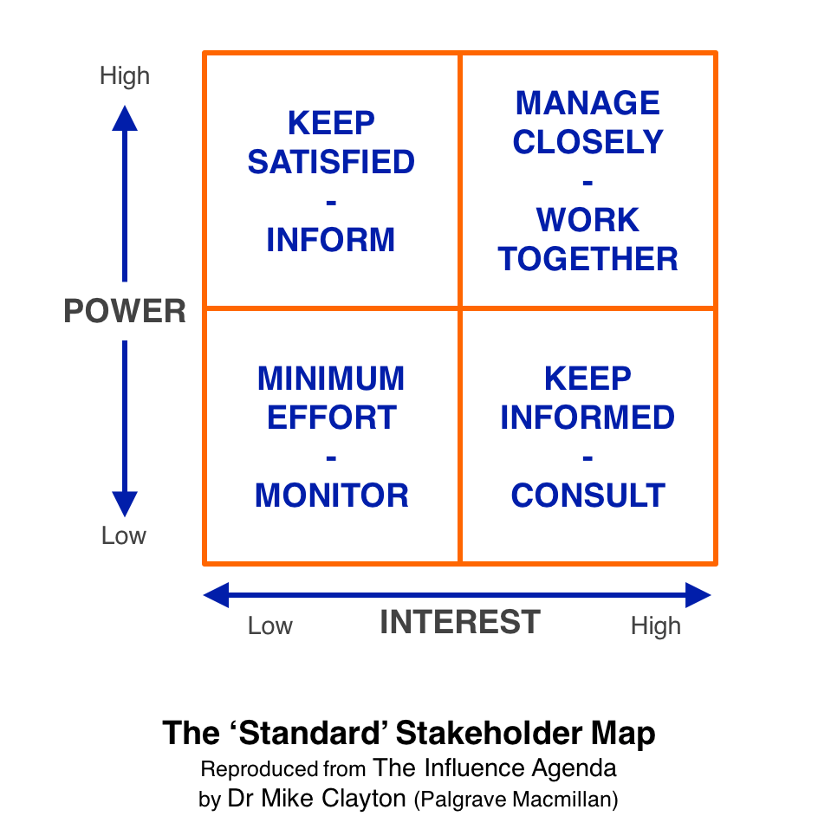

**MANAGE**

**Key stakeholders who should be fully engaged through full communication and consultation  
  
INVOLVE**

**Voices need to be heard, e.g. patients. You may need to take pro-active steps by organising them into groups or active consultation work  
  
SATISFY**

**Opinion formers. Keep them satisfied with what is happening and review your analysis of their position regularly  
  
INFORM/MONITOR**

**Not crucial to the process but useful to keep informed**

Project Partners

e.g. Aberdeen City Council

University of Aberdeen

Internal

e.g. NHSG Board

Project Board

NHSG Asset Management Group  
  
External

e.g. Scottish Ambulance Service

Police Scotland

Grampian Fire and Rescue

CIG, SGHSCD

HFS – Health Facilities Scotland

Press/local media

Community Councils

Staff

Services / Departments

Admin

Facilities

Corporate Communications

Spiritual Care

HR

Finance

FM/Portering

Public / Patient Groups

Patients / service users of service

Family / carers of service users

Public Representatives

Public Involvement Network

Local community / Wider pubilc

Committees/Groups/Third Sector

Clinical/Advisory Committees

Other Health Boards (Orkney, Shetland, Tayside, Highland etc.)

Healthcare Improvement Scotland – Community Engagement

NOSPG - North of Scotland Planning Group

NES – NHS Education for Scotland

GHAT – Grampian Hospital’s Arts Trust

TSIs – ACVO / AVA / TSI Moray

Scottish Government

MPs/MSPs

Local Authorities – Aberdeenshire, Moray, Orkney, Shetland

Primary care

Health and Social Care Partnerships

Community Councils  
University of Aberdeen / RGU

Schools / colleges