

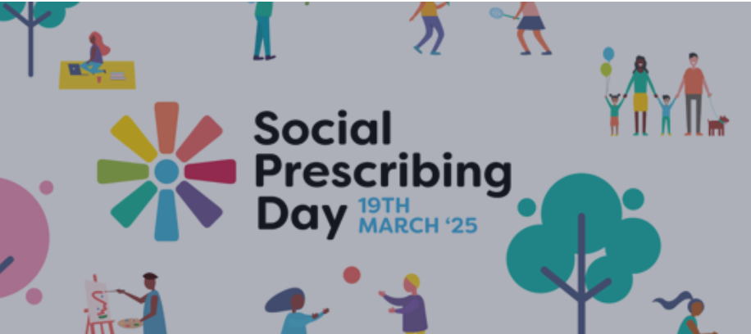

[The National Academy for Social Prescribing](https://socialprescribingacademy.org.uk/what-is-social-prescribing/social-prescribing-day-2025/) is celebrating people, organisations and communities who make social prescribing happen.

Across Grampian there are several social prescribing projects taking place whether as part of the National GP Link Worker Programme or piloting further aspects of social prescribing to connect people into non-medical support.

[The North East Place and Wellbeing Network](https://www.nhsgrampian.org/about-us/planforthefuture/what-we-intend-to-do/places/examples-of-whats-good-in-grampian/the-north-east-place-and-wellbeing-network/) has been focusing over the past year to explore the obstacles and challenges in setting up a model of practice to enable a ‘Social Prescription’ to take place.

Social Prescribing is an interchangeable phrase and to fully understand what we mean when we refer to social prescribing we need to look at the international understanding of social prescribing.

Social prescribing is…

*‘a means for trusted individuals in clinical and community settings to identify that a person has non-medical, health-related social needs and to subsequently connect them to non-clinical supports and services within the community by co-producing a social prescription—a non-medical prescription, to improve health and well-being and to strengthen community connections.’* **Caitlin Muhl et al. BMJ Open 2023;13:e070184**

**There are four key roles:**

***The Identifier*** – Identifies the person has non-medical, health-related social needs e.g. issues with housing, food, employment, income, social support.

***The Connector*** – Connects the person to non-clinical support and services within the community by co-producing a non-medical prescription.

***The Service User*** – The Service User is the person requiring the non-medical support.

***The Service Provider*** – The Service Provider is the agency or group providing the non-medical support.

At one end of the spectrum social prescribing can be a simple informal ‘sign-post’ whether by a friend, family member, a member of the community or even a health care professional. The other end of the spectrum of social prescribing is an actual referral from a health care professional/link worker and passing relevant and appropriate information about the person with full consent of the person to the community asset delivering the non-medical support.

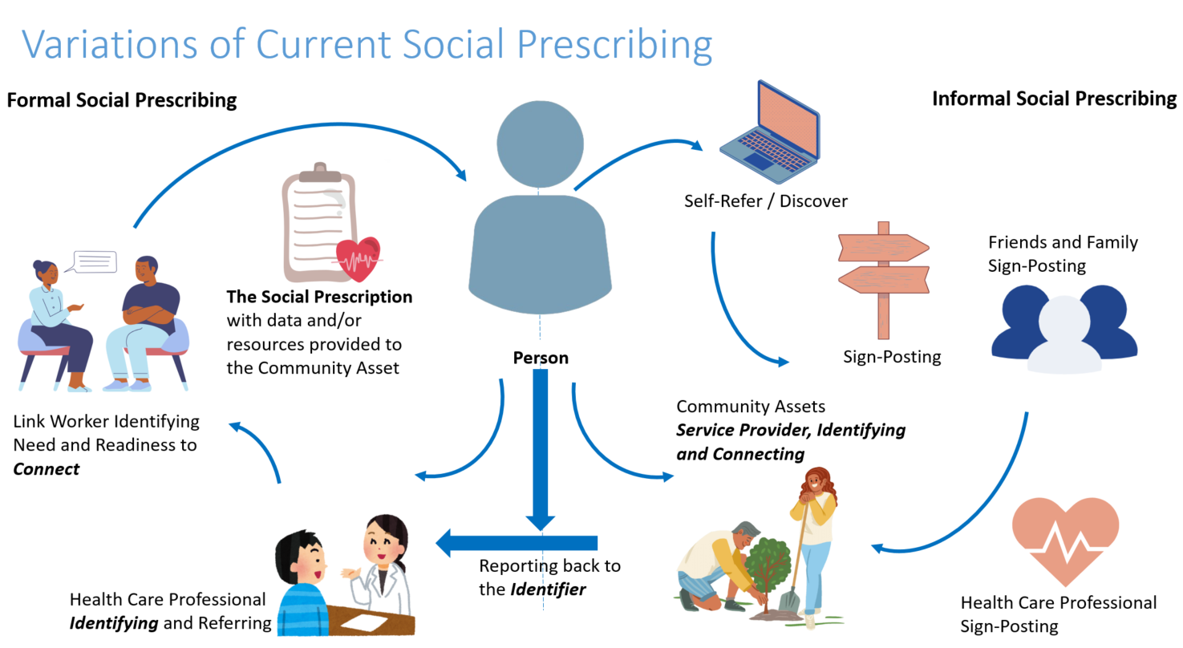

If you are interested to learn more about some of the initiatives being developed across Grampian or would like to know more how to enable social prescribing in your community please get in touch alison.hannan2@nhs.scot