The Health and Wellbeing of people living in Grampian in 2024
This document has been produced to provide additional context for the Director of Public Health Annual Report 2024

Contents
Introduction 4
Health Overview 4
Life Expectancy 4
Scotland 4
Grampian 5
Council area 6
Impact of deprivation on life expectancy 8
Healthy Life Expectancy 10
Scotland 10
Grampian 10
Mortality 13
Death Rates (All Ages) 13
Death rates (children) 15
Grampian population trends in children 15
Infant Mortality Rates 17
Birth versus deaths trends comparison 18
Causes of death in children 20
The burden of disease in Scotland: Forecast 21
Maternal health 22
Maternal obesity 22
Child Health 23
Child healthy weight 23
Health Inequalities in Grampian 25
Childhood poverty 25
Women smoking during pregnancy 26
Vaccination uptake and deprivation 27
Oral health 28
Avoidable & Preventable Deaths 29
Mental Health and wellbeing 30
Child and Adolescent Mental Health Services (CAMHS) referrals and trends 30
School surveys 31
Happiness 31
Low Mood 34
Risk of Depression 37
Strength and difficulties 38
Loneliness 40
Self-Harm 42
Developmental concerns 44
References 46

Introduction
This document brings together information to describe the population characteristics of Grampian and the evidence base to provide context for the 2024 Director of Public Health Annual Report. The purpose of the document is to provide additional detail for those seeking more information about the Health and Wellbeing in Grampian and the four key themes discussed in the DPH annual report.

Health Overview

Life Expectancy

Scotland
For the most part of the 20th century, life expectancy increased year on year (with the exception of the impact of the world wars). That steady increase in life expectancy continued across the UK, and Scotland, until 2010. Since 2008-2010, the improvement in life expectancy started to slow and, from 2012-2014 until 2017-2019, improvement in life expectancy stalled. Scotland has the lowest life expectancy in Western Europe and, over the last decade, the gap has widened with other European countries.
The gap in life expectancy between the most and least deprived in Scotland has continued to widen. For males in 2021-2023 the difference was 13.2 years between the most and least deprived deciles. For females the difference was 10.5 years.
Most recent figures (2021-2023) for Life Expectancy in Scotland (figure 1) show that this has increased to 80.8 years for females and 76.8 years for males since 2020-2022 but remains below that of the pre-pandemic years.

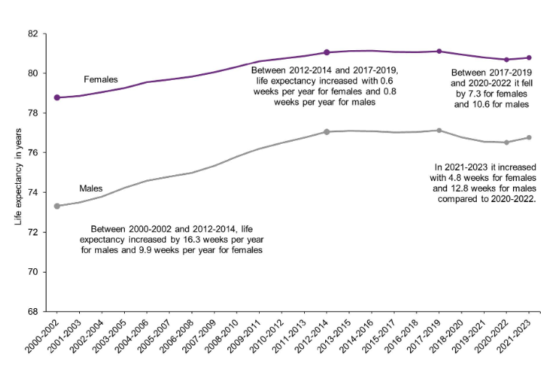
Figure 1: Life Expectancy in Scotland

Grampian
Life expectancy in Grampian in general is higher than the Scottish average, and female life expectancy is higher than male life expectancy.
For the period 2021-23 male life expectancy in Grampian was 78.2 years compared to 76.8 years across Scotland. Female life expectancy was 81.9 years compared to 80.8 years across Scotland.
Whilst the male life expectancy in Grampian improved from 70.7 years in 1981-83 to peak at 78.5 years in 2017-19, it fell to just over 78 years in subsequent time periods and has remained fairly stable (figure 2). Similarly, female life expectancy in Grampian improved from 76.6 years in 1981-83 to peak at 82.1 years in 2016-18 before falling to just below 82 years in subsequent time periods and has remained fairly stable (figure 3).
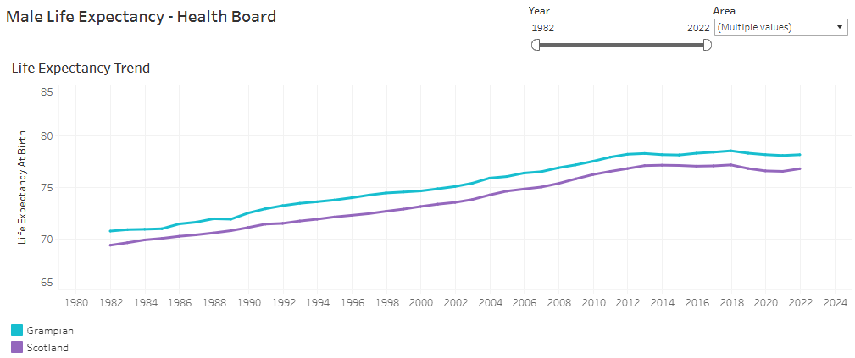
Figure 2: Male Life Expectancy in Grampian

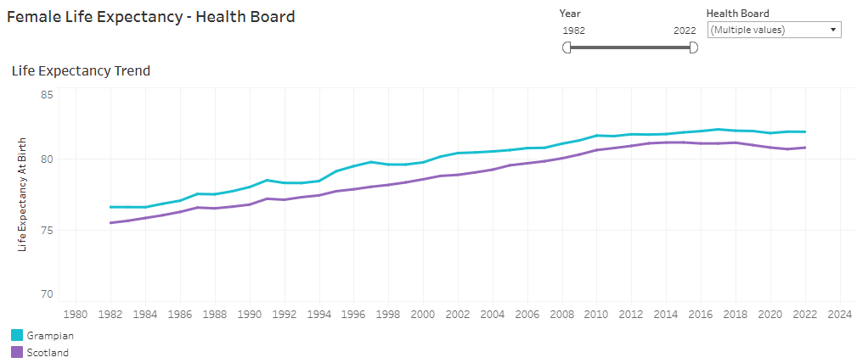
Figure 3: Female Life Expectancy in Grampian

Council area
In Grampian, male life expectancy is highest in Aberdeenshire, at 79.3 years for 2021-23 (figure 4). This was the third highest life expectancy amongst Scottish council areas. Moray also has life expectancy above the Scottish average. Aberdeen City has lower life expectancy that peaked in 2009-11 and then began to stall earlier than in other areas. Since 2004-5, the trend in Aberdeen City has been very similar to the Scottish average (figure 5).
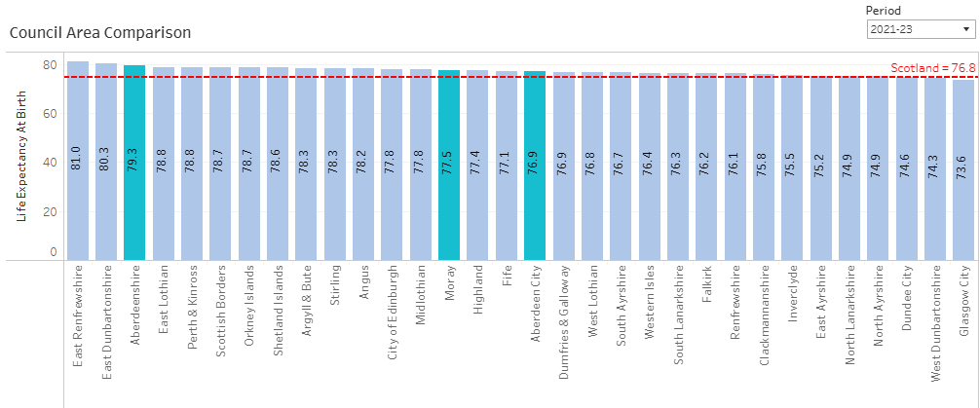
Figure 4: Council Area Comparison of Male Life Expectancy

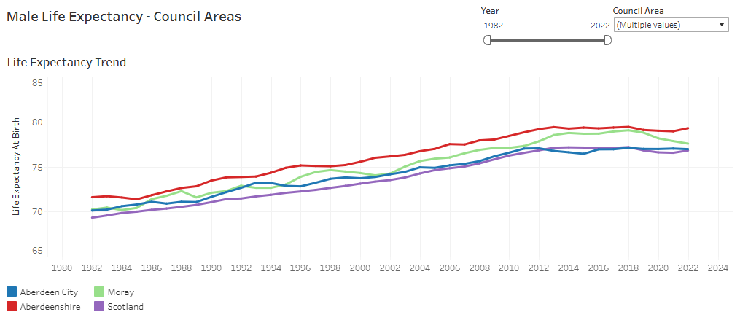
Figure 5: Male Life Expectancy by Council Area across Grampian

In Grampian, female life expectancy is highest in Aberdeenshire, at 82.7 years for 2021-23 (figure 6). This was the fourth highest life expectancy amongst Scottish council areas. Moray also has life expectancy above the Scottish average. Aberdeen City has lower life expectancy and, as with for males, this began to stall earlier than in other areas. Since 2012, the trend in female life expectancy has been similar to the Scottish average (figure 7).

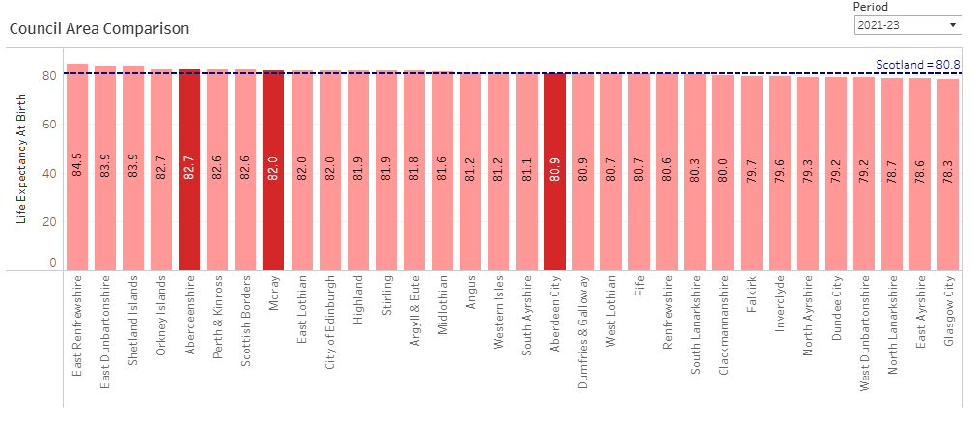
Figure 6: Council Area Comparison of Female Life Expectancy

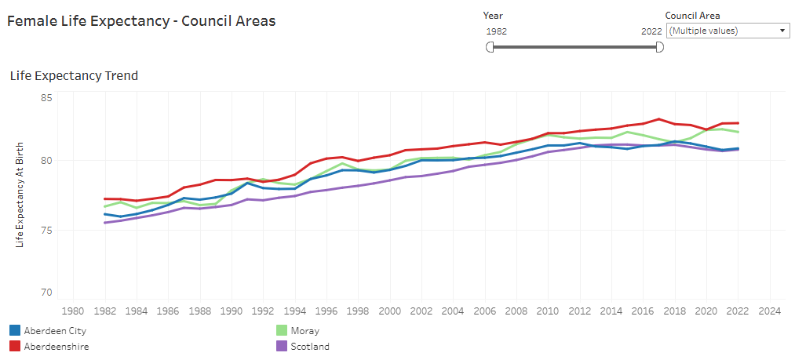
Figure 7: Female Life Expectancy by Council Area across Grampian

Impact of deprivation on life expectancy
The impact of wider health determinants such as social deprivation on life expectancy is well recognised and underpins the Health Equity work outlined in the NHS Grampian Plan to reduce the gap in healthy life expectancy between the most and least deprived communities. Male life expectancy is considerably lower in the more deprived quintiles (figure 8). This is particularly noticeable in Aberdeen City where life expectancy, for the period 2019-23, was 9.4 years lower in the most deprived quintile than in the least deprived quintile (figure 9). Similarly, female life expectancy is also lower in the most deprived quintile but the difference is less marked than with males.

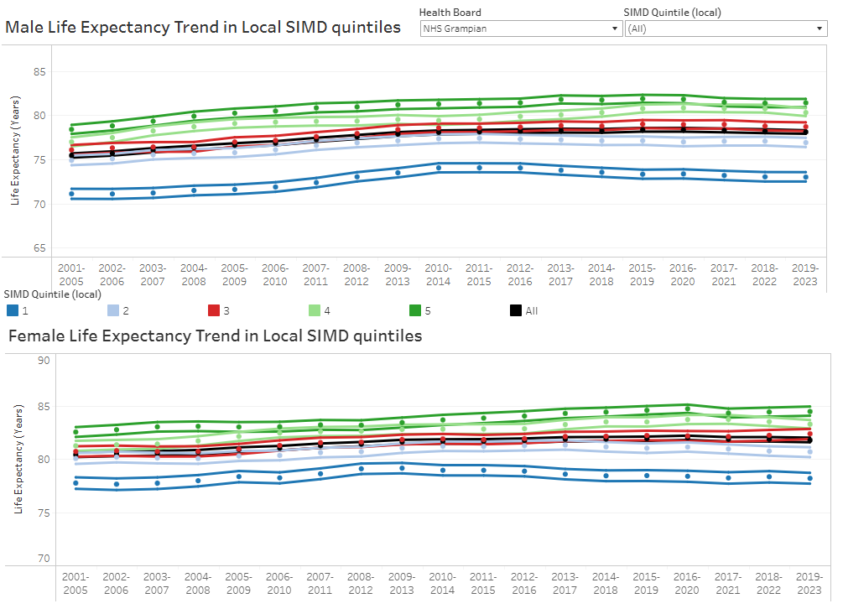
Figure 8: Male and Female Life Expectancy by local SIMD quintiles

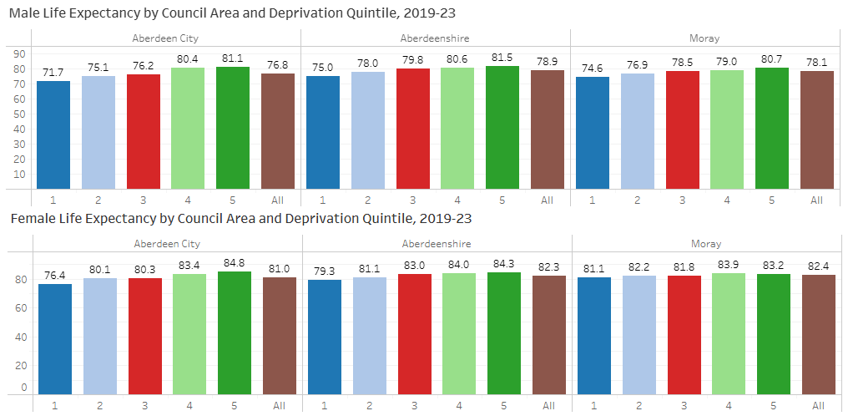
Figure 9: Female and Male Life Expectancy by Council Area and Deprivation Quintile

Healthy Life Expectancy

Scotland
The amount of time people spend in good health has been decreasing. Healthy life expectancy is the average number of years that an individual is expected to live in a state of self-assessed good or very good health, based on current mortality rates and prevalence of good or very good health. In Scotland this has fallen over the last decade.
Information on the Healthy Life Expectancy in Scotland was recently published by NRS . As shown in figure 10, taken from this publication, as age increases, life expectancy and healthy life expectancy both decrease. The difference in the proportion of life in good health between males and females narrows as age increases.
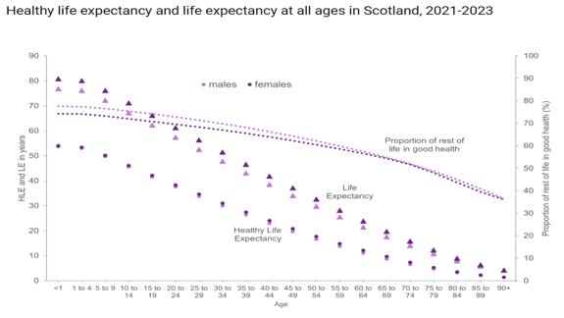
Figure 10: Health life expectancy and life expectancy at all ages in Scotland, 2021 - 2023. As age increases, the proportion of remaining life expectancy spent in good health decreases

Grampian
For the period 2021-23, males could expect to live 61.6 years in good health (figure 11) and females 62.3 years (figure 12). This compared favourably with the whole of Scotland (59.6 years and 60.0 years, respectively) but represented a decline compared to the period 2013-15.
Healthy life expectancy in Grampian declined by 3.3 years for males and 3.9 years for females between 2013-15 and 2021-23 (figure 13). This decline was greatest in Aberdeen City with females living 7.5 fewer years in good health (58.1 years compared to 65.7 years) and males 5.8 years fewer (58.0 years compared to 63.8 years).
This means that male healthy life expectancy in Aberdeen is now 1.6 years lower than the Scottish average. In 2013-15, male HLE in Aberdeen City was 1.9 years higher than the average for Scotland. Female HLE was 1.9 years lower than across Scotland in 2021-23 compared to 2.7 years higher in 2013-15.
In Aberdeenshire and Moray, the decline in healthy life expectancy, of between 1.3 and 2 years, was less than the Scotland wide decline of between 2.3 and 3 years (figure 13).
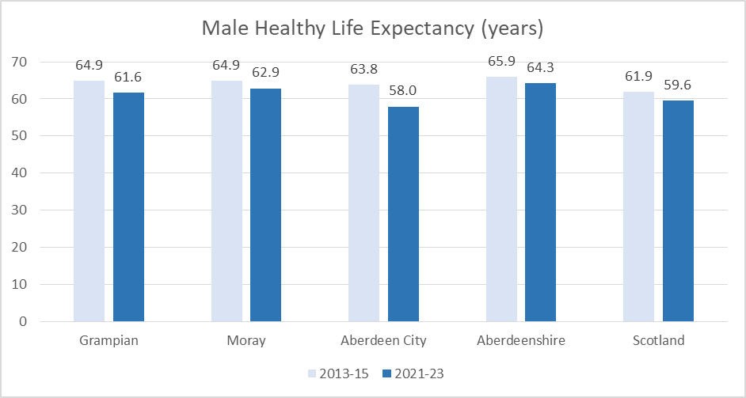
Figure 11: Male Healthy Life Expectancy Comparison

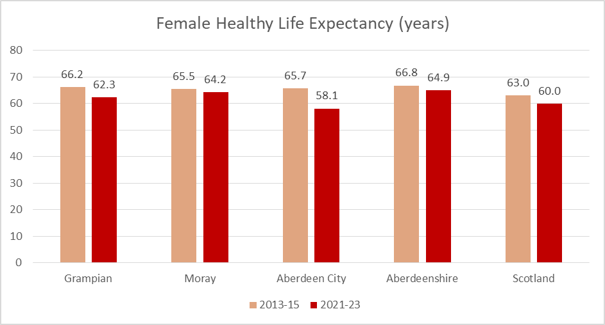
Figure 12: Female Healthy Life Expectancy Comparison
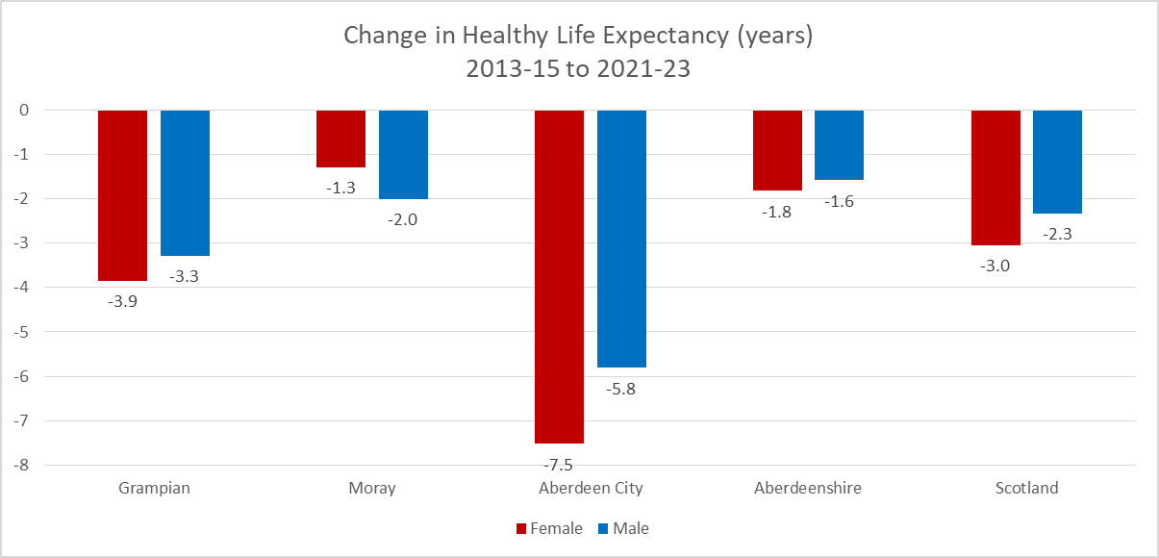
Figure 13: Change in Health Life Expectancy between 2013-15 and 2021-23

The proportion of life females spend in good health dropped by over nine percentage points in Aberdeen City between 2013-15 and 2021-23 (figure 14). This resulted in the proportion going from 3.4 percentage points above the Scottish average to 2.4 percentage points below. Smaller declines of 2-3 percentage points were recorded in Aberdeenshire and Moray.

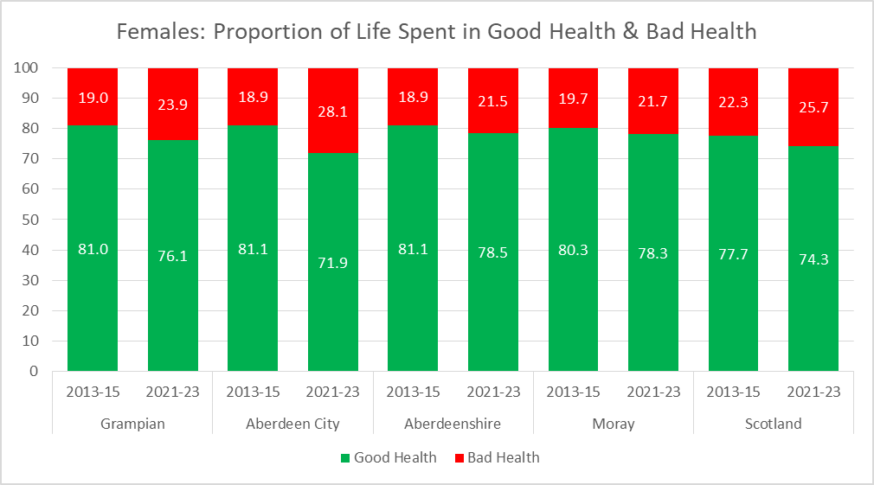
Figure 14: Proportion of Life Spent in Good Health and Bad Health in Females

For males, the percentage of life spent in good health dropped by 8 percentage points in Aberdeen City, between 2013-15 and 2021-23 resulting in the healthy proportion going from three percentage points above the Scotland wide figure to 1.8 percentage points below (figure 15). In Aberdeenshire and Moray 1-2 percentage point decreases were observed.
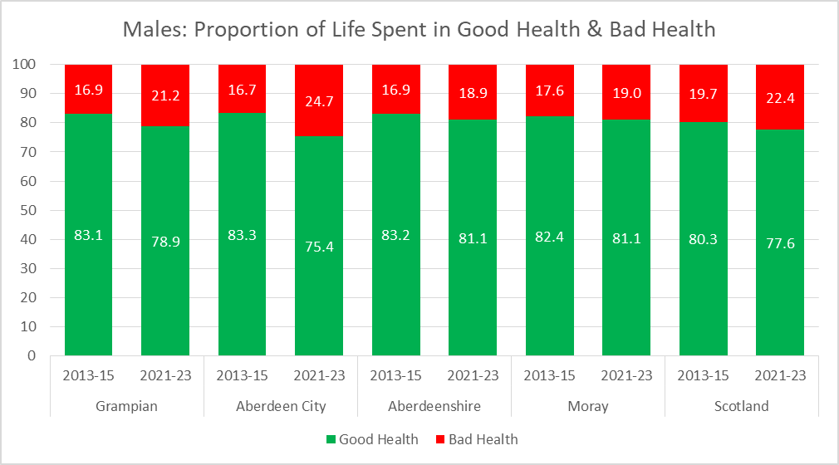
Figure 15: Proportion of Life Spent in Good Health and Bad Health in Males

Mortality

Death Rates (All Ages)
The under 65 year old male age standardised death rate halved between the 1980s and 2015 before gradually rising (figure 16). A similar, but less dramatic trend is evident amongst females aged under 65. A similar trend is evident amongst over 65s (figure 17).
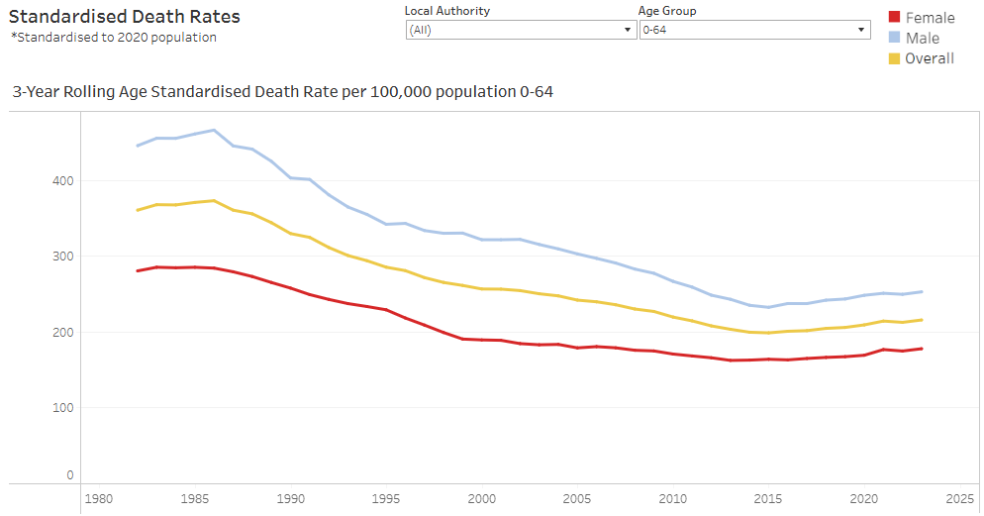
Figure 16: 3 year rolling Age Standardised Death Rate per 100,000 population aged 0-64 years

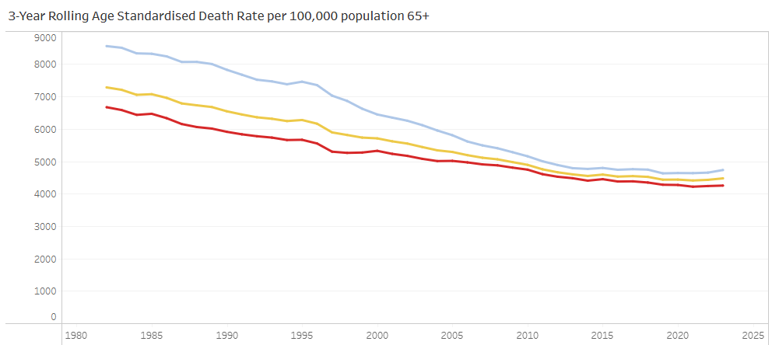
Figure 17: 3 year rolling Age Standardised Death Rate per 100,000 population aged 65+

Death rates (children)
The death rate for under 5s halved between 2004 and 2019 but has risen by 50% since then (figure 18). An increase has also been seen amongst 5-11 year olds but not amongst 12-17 year olds.

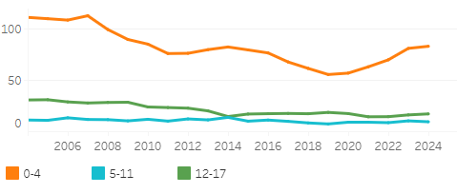
Figure 18: Death Rates per 100,000 population (rolling 5 year averages)

Grampian population trends in children
There was a 10% decrease in the under 18 year’s population between 1995 and 2012 (figure 19). By 2025 the population had increased by 3% from the low point despite a further decline since 2023.
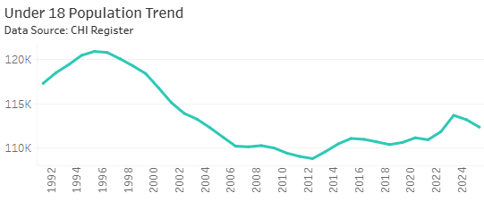
Figure 19: Under 18 Population Trend

Between 2014 and 2025, the under 5 years population in Grampian declined by 23% (figure 20). This is consistent with a marked decline in births over the same period (figure 21). Both the number of births and the birth rate dropped by over 30% between 2015 and 2024, equivalent to 2000 fewer births per annum.
By contrast the 5-11 and 12-17 years populations have increased over the past decade.
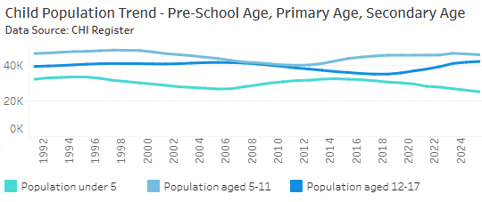
Figure 20: Child Population Trend

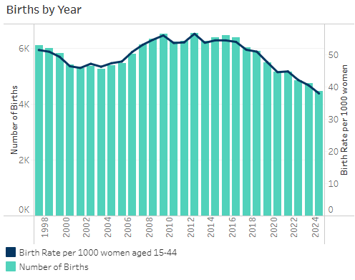
Figure 21: Births by Year

Infant Mortality Rates

The infant mortality rate, per 100,000 live births in Grampian, was 88% higher for the period 2020-24 compared to 2015-19 and was the highest for any five year period since 2004-08 (figure 22).

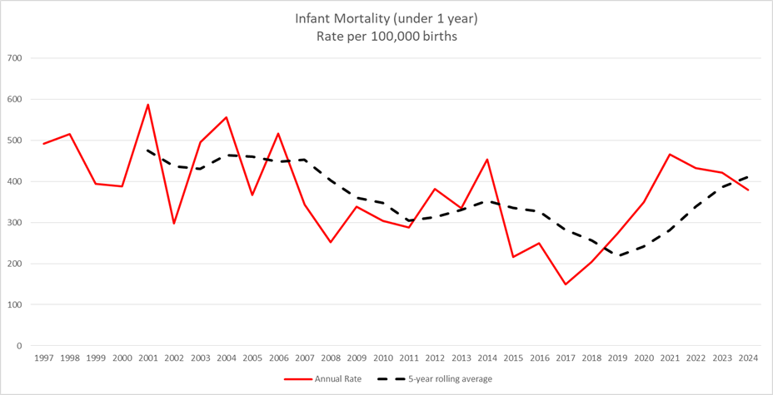
Figure 22: Infant Mortality Rate per 100,000 births

Infant mortality rates are highest in the most deprived quintile (quintile 1) but increases since 2020 has been observed in the least deprived quintiles also (e.g. 4 and 5) (figure 23).

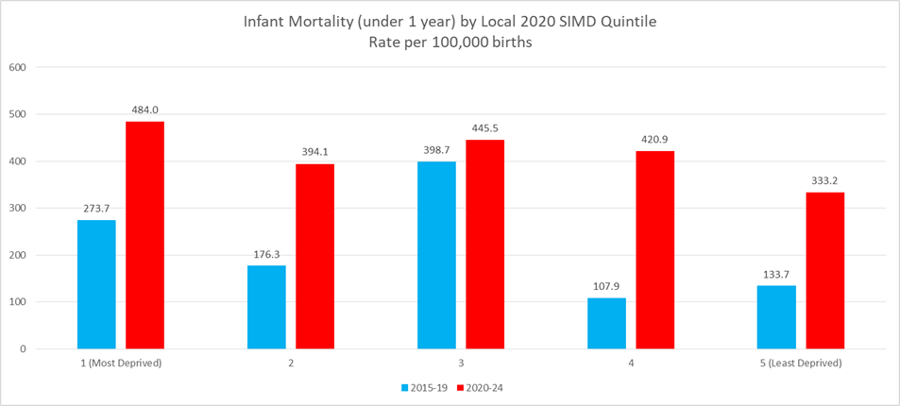
Figure 23: Infant Mortality Rate by local SIMD quintile rate per 100,000 births

All quintiles, expect the middle quintile (3) saw a statistically significant increase in infant mortality rates between 2015-19 and 2020-24. The least deprived quintiles saw infant mortality rates more than double (figure 24).

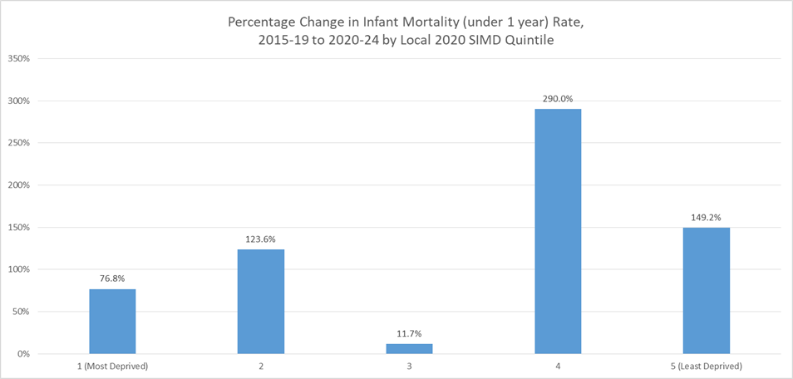
Figure 24: Percentage Change in Infant Mortality rate from 2015-19 to 2020-24 by local SIMD quintile

Birth versus deaths trends comparison
Until recently the number of births in Grampian have exceeded deaths each year, but starting in 2019 the number of deaths have been greater than births, and they are now trending in opposite directions (figure 25). This is particularly noticeable in Moray, every year from 2010 onwards where there is a clear divergence in trend (figure 26).
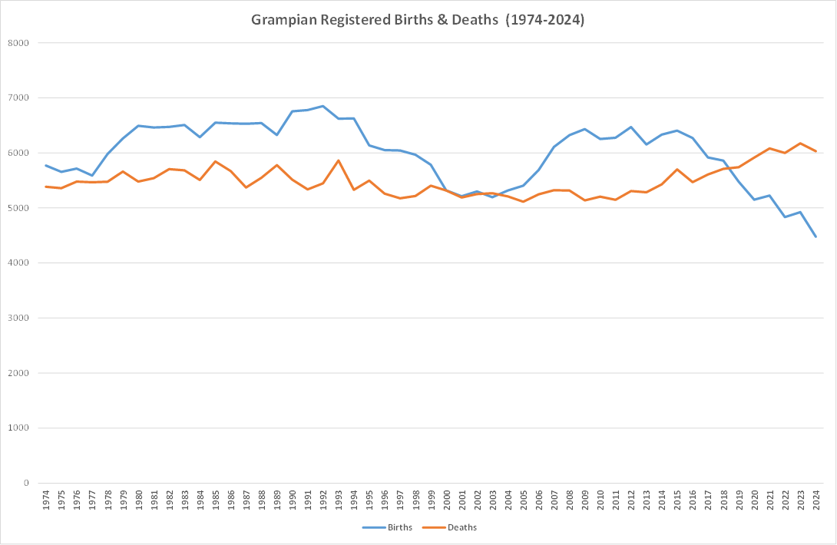
Figure 25: Grampian Registered Births and Deaths

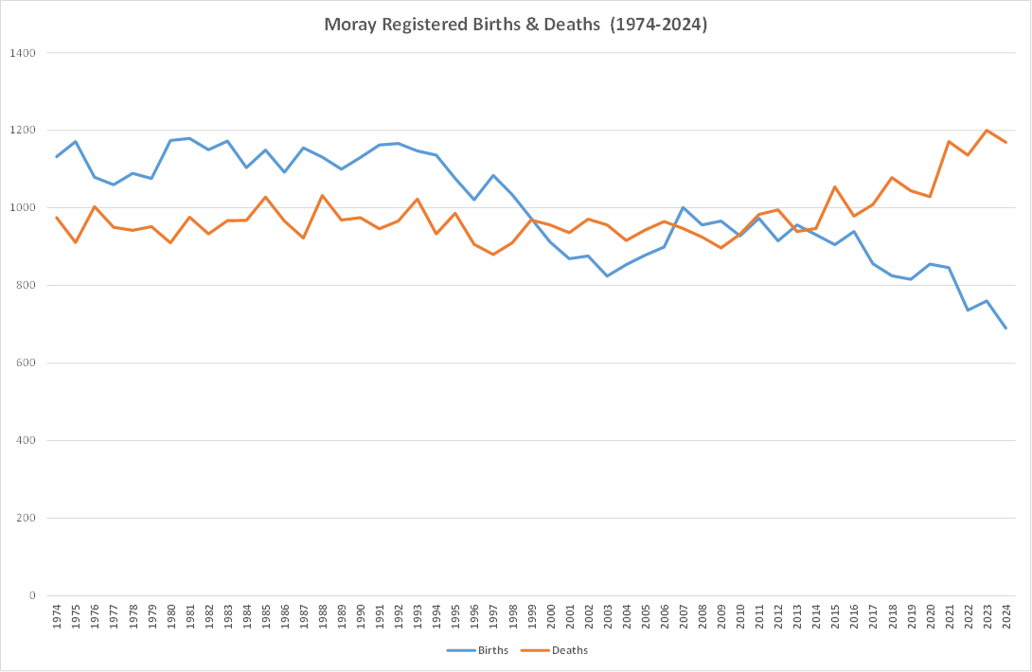
Figure 26: Moray Registered Births and Deaths

Causes of death in children

Most common causes
The most common causes of death in children (aged under 18) are those related to the perinatal period and congenital abnormalities (figure 27).
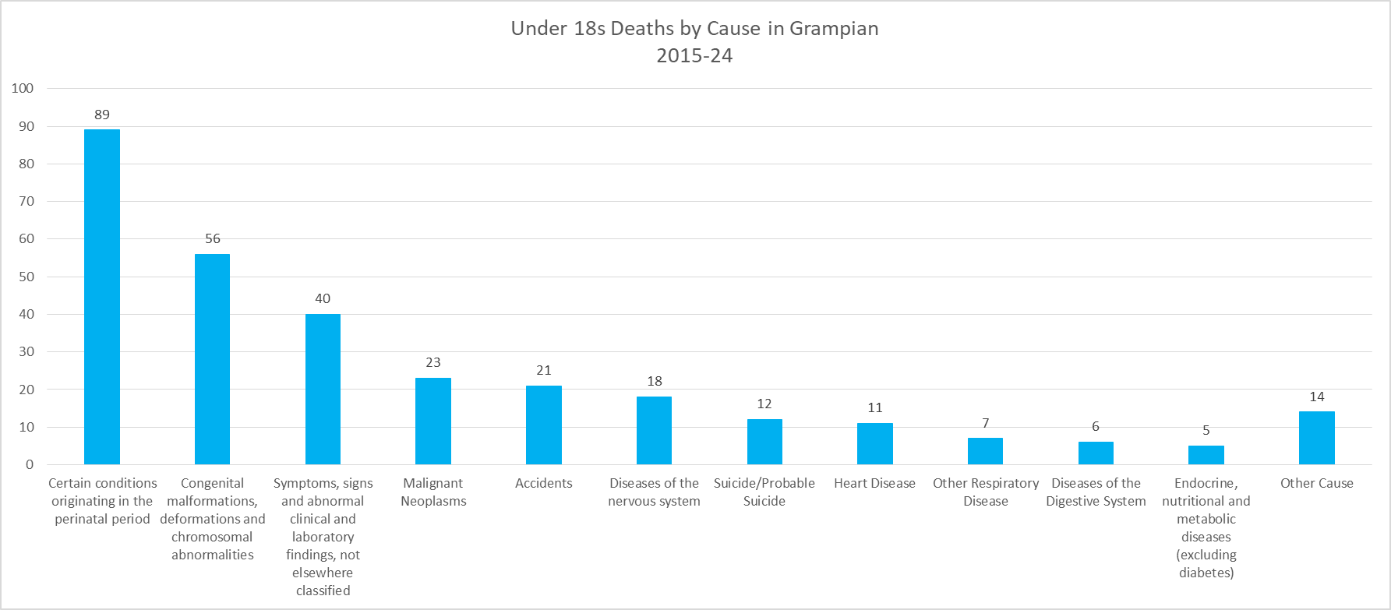
Figure 27: Under 18s Cause of Death

Suicide rates have remained relatively constant since 2006 and have fallen in the most recent years, which is reassuring (figure 28).
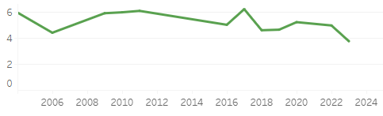
Figure 28: Suicide Rates per 100,000 population aged 12-17 (rolling 5 year average)

The burden of disease in Scotland: Forecast
Burden of disease forecasts are important to inform how we identify and define our public health priorities and shape our services to meet the changing needs of our population. A 21% increase in the burden of disease is forecasted in Scotland between 2019 and 2043, with the largest increase being seen in those age 65 years and above. This ageing population is already evident in Grampian and is impacting pressures on services for the elderly.
This increase is forecasted to be driven in the main by increases in particular conditions: cardiovascular diseases; cancers; neurological disorders; chronic respiratory diseases; diabetes and kidney diseases; and common infectious diseases.
Whilst the burden of disease in the under 15 year and 16-24 year age groups is forecast to fall this prediction does not take into consideration worsening of causative factors such as the impact of the COVID-19 pandemic on childhood obesity and its contribution to the failure to reduce the rise in obesity in primary-school aged children. This impact will lead to a worsening of the epidemiology trend and an under estimation of the forecasts for the obesity-attributable disease burden.

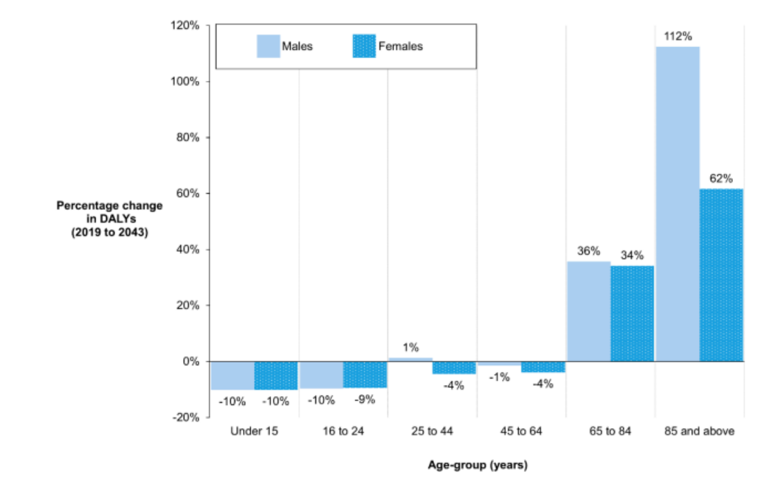
Figure 29: Forecast Percentage Change in DALYs by age group

Maternal health

Maternal obesity
The data highlights a clear socioeconomic gradient in maternal obesity rates. In the most recent period, 2021/22 to 2023/24, women in the second most deprived quintile have the highest prevalence of maternal obesity at 33.1%, while those in the least deprived quintile have the lowest at 21.5% (figure 30). This pattern is consistent across all groups, with a steady decline in obesity rates as deprivation decreases.
The trend over time shows that maternal obesity has increased across all groups. The rise has been steeper and more sustained in the most deprived areas, with the second most deprived group consistently higher than the most deprived area since 2018-19 to 2020-21. The gap between the most and least deprived groups has widened to 10 percentage points, indicating that inequalities in maternal health are not only persistent but potentially growing.

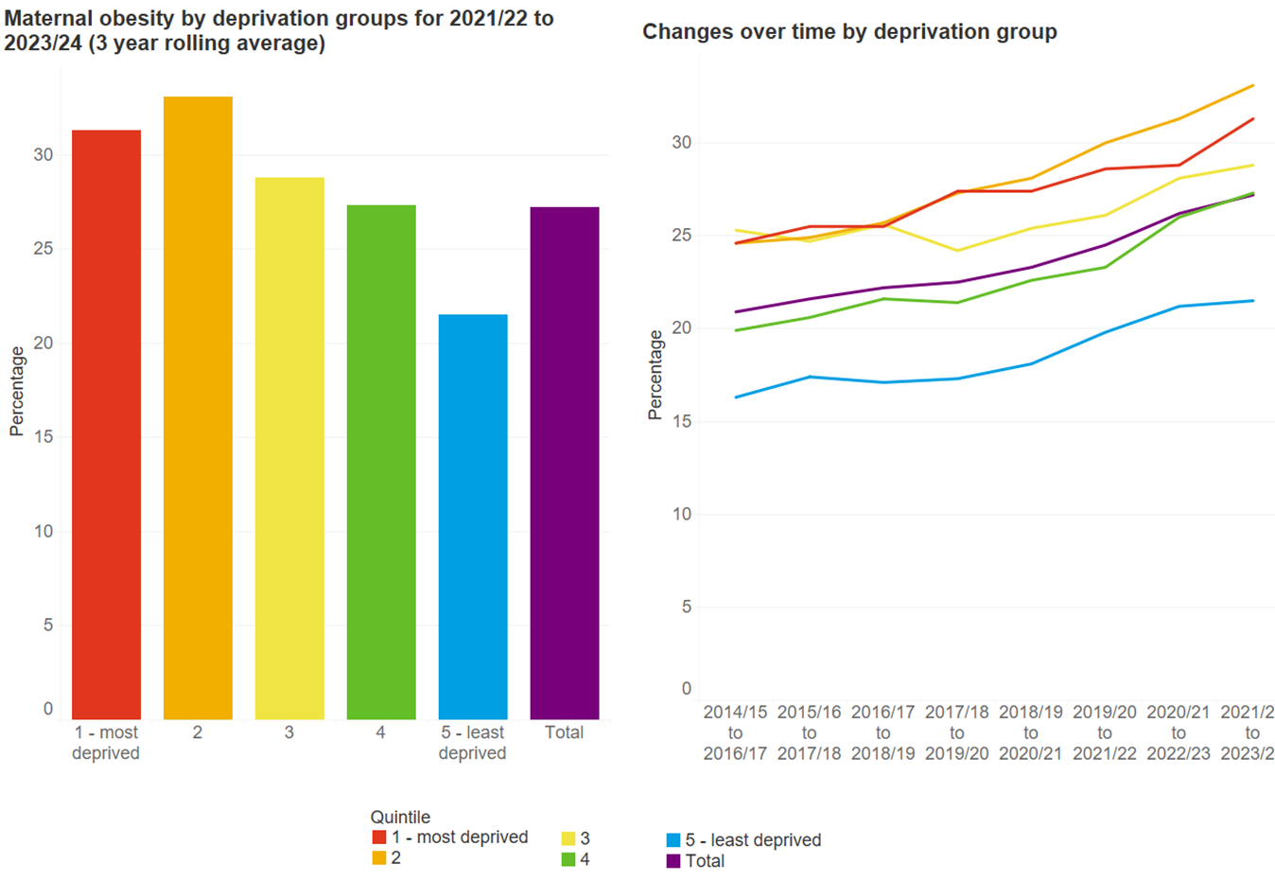
Figure 30: Maternal obesity trends between deprivation groups

Child Health

Child healthy weight
78% of Primary 1 children were a healthy weight in 2023, 12% were overweight and 9% obese (figures 31 and 32).

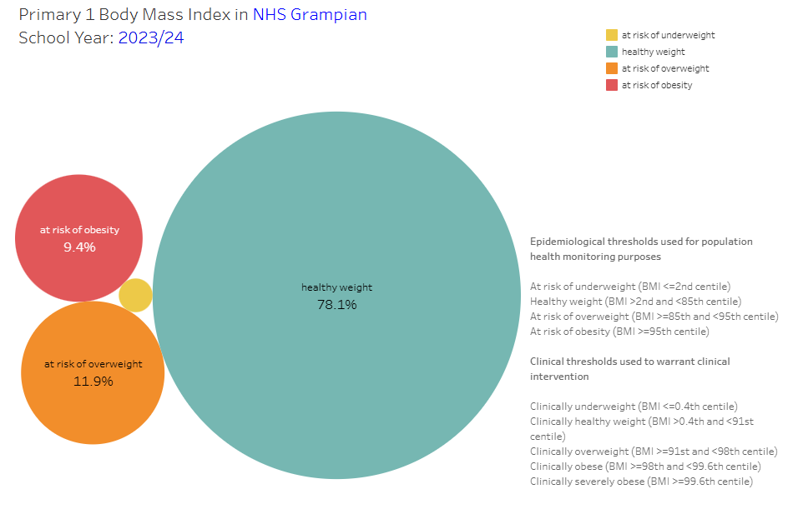
Figure 31: Primary 1 Body Mass Index in Grampian

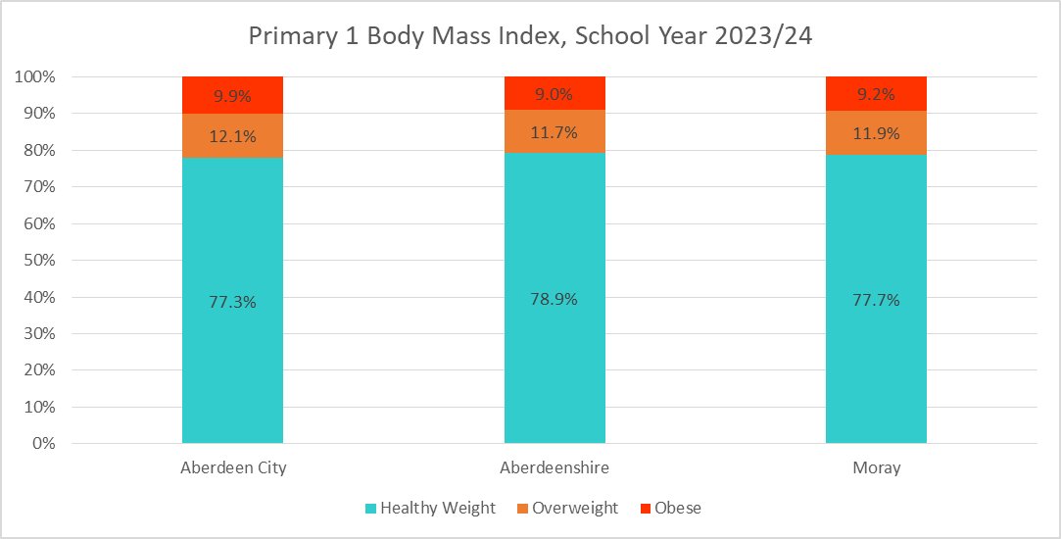
Figure 32: Primary 1 Body Mass Index in 2023/24

The proportion of Primary 1 pupils who are overweight or obese peaked at 24.7% in 2013/14 before falling to 21.2% in 2023/24 (figure 33).
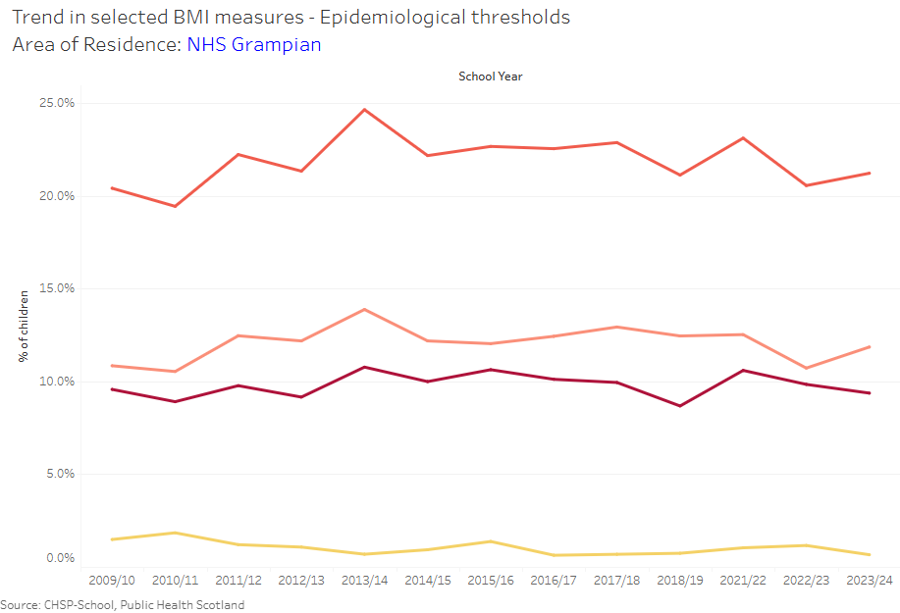
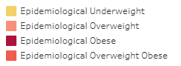
Figure 33: Epidemiological Body Mass Index Trends

Health Inequalities in Grampian
This section provides information to demonstrate the importance of health inequality in determining of the quality of life a child and adult experience, and how it is can influence multiple aspects of an individual’s life. This section in general focuses on the key themes outlined in the DPH Annual Report and provides examples which are of relevance to different stages of a child’s life course.

Childhood poverty
The proportion of children living in poverty decreased between 2022/23 and 2023/24 across all three local authorities in Grampian (figures 34 and 35).

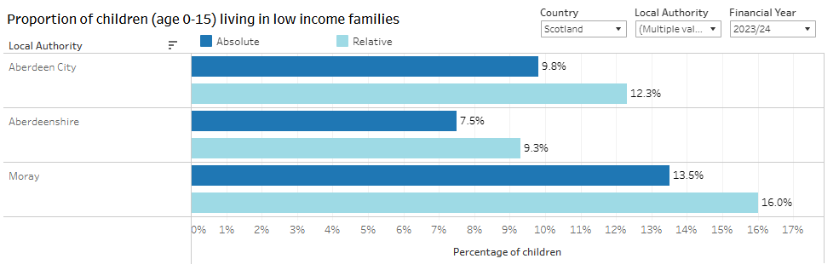
Figure 34: Proportion of children aged 0-15 living in low income families in 2023/24

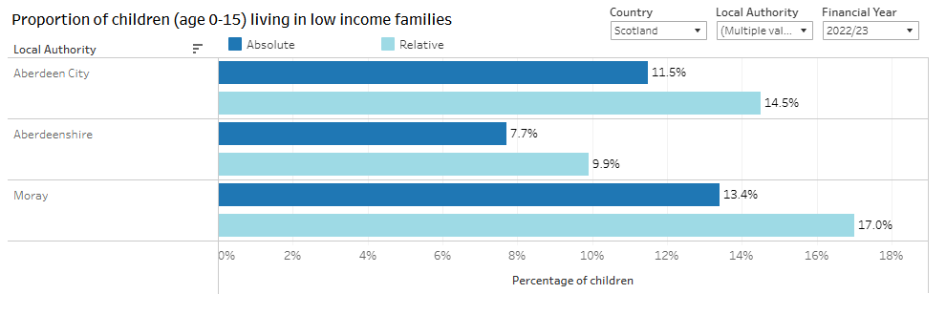
Figure 35: Proportion of children aged 0-15 living in low income families in 2022/23

Women smoking during pregnancy
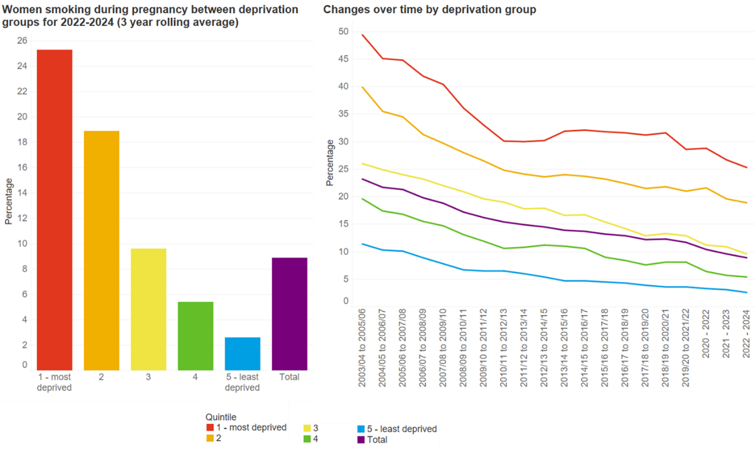

Figure 36: Women smoking during pregnancy by deprivation quintile

The data highlights a persistent and significant disparity in smoking during pregnancy across deprivation groups (figure 36). In the most recent period (2022–2024), women in the most deprived quintile are ten times more likely to smoke during pregnancy (25.6%) compared to those in the least deprived quintile (2.6%). This stark contrast underscores the ongoing impact of socioeconomic factors on maternal health behaviours.
Looking at the long-term trend from 2003/04 to 2022-24, there has been a steady decline in smoking rates across all deprivation groups. The most deprived group has seen a reduction from 49% to 25%, while the least deprived group dropped from 11% to 2.6%. Despite this overall improvement, the relative gap between groups remains wide, decreasing from 38 percentage points to 23, suggesting that while interventions may be working, they are not closing the inequality gap.

Vaccination uptake and deprivation
Vaccination uptake tends to be much higher in the least deprived areas than in the most deprived areas and the difference grows with age (figure 37). For 6-in-1 at 12 months there was a differential of 4.9 percentage points in 2024. This compared to a 7.6 percentage point differential for MMR1 (24 months) and 14.7 percentage point differential for MMR2 (5 years).

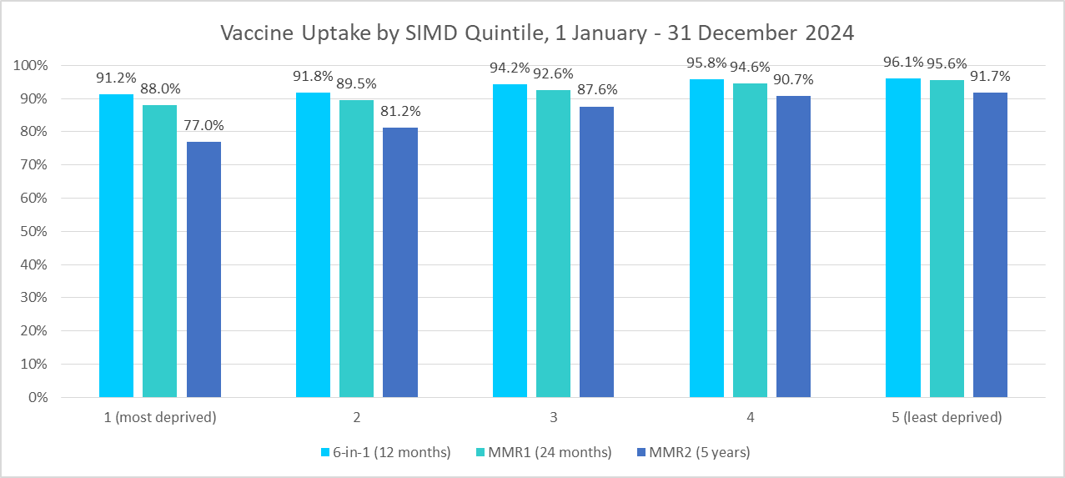
Figure 37: Vaccine Uptake by SIMD quintile in 2024

Vaccination rates are lower in Aberdeen City, reflecting higher levels of deprivation, but only for MMR1 (24 months) and MMR2 (5 years) see figure 38.

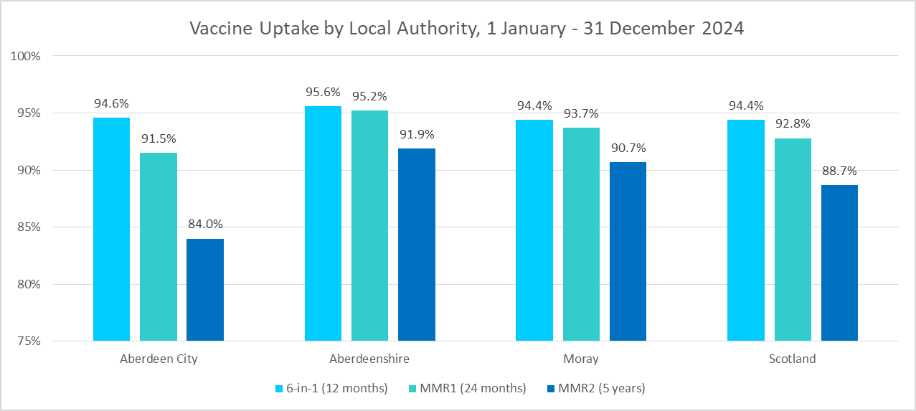
Figure 38: Vaccine Uptake by Local Authority in 2024

Oral health
Inpatient admissions for tooth extractions are considerably higher in the most deprived quintile and the differential has grown since 2012 (figure 39).

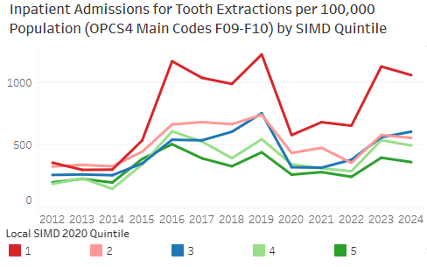
Figure 39: Inpatient Admissions for Tooth Extractions per 100,000 population by SIMD quintile

Avoidable & Preventable Deaths
The avoidable mortality rate is 2.5 times higher in the most deprived quintile compared to the least deprived quintile (figure 40).
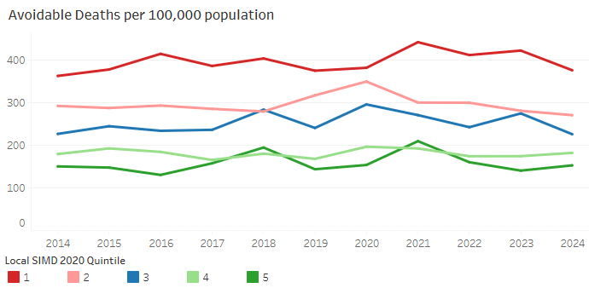
Figure 40: Avoidable Deaths per 100,000 population by SIMD quintile

The preventable mortality rate is 2.7 times higher in the most deprived quintile compared to the least deprived quintile (figure 41).

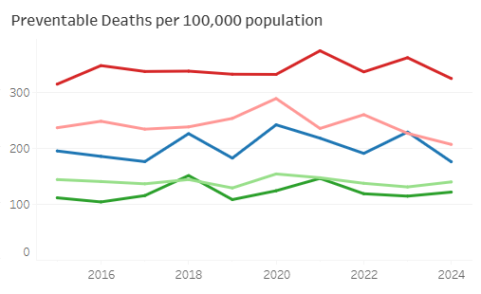
Figure 41: Preventable Deaths per 100,000 population by SIMD quintile

Mental Health and wellbeing

Child and Adolescent Mental Health Services (CAMHS) referrals and trends

Referrals have remained consistently higher among females than males from 2022 to 2024, though the gender gap has narrowed slightly due to a slight increase in male referrals. The most common age group referred continues to be 12-15 year olds, highlighting early adolescence as a key period of need. However, referrals for children aged 5-11 have increased year on year, suggesting a rising demand in younger age groups (figure 42 & 43).
Socioeconomic differences remain high, with referral rates consistently higher among children from the most deprived areas compared to those in the least deprived. In 2024, there were almost double the number of referrals from the most deprived quintile compared to the least deprived quintile (figure 42).
Aberdeenshire consistently accounts for the highest referral volume, with Aberdeen City increasing steadily since 2022 (figure 42).

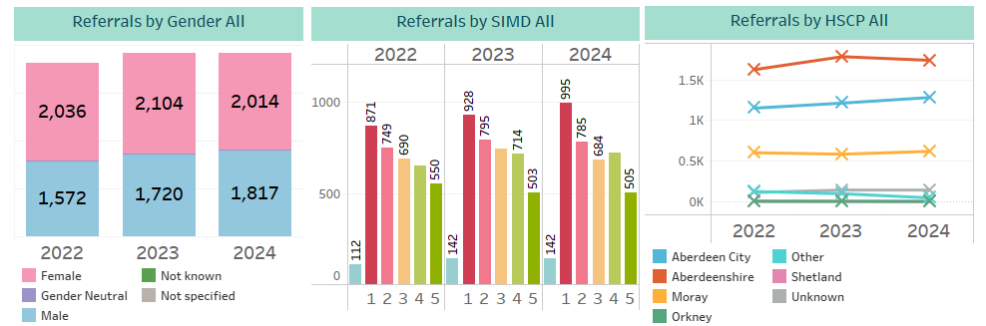
Figure 42: CAMHS Referrals across Grampian between 2022-2024

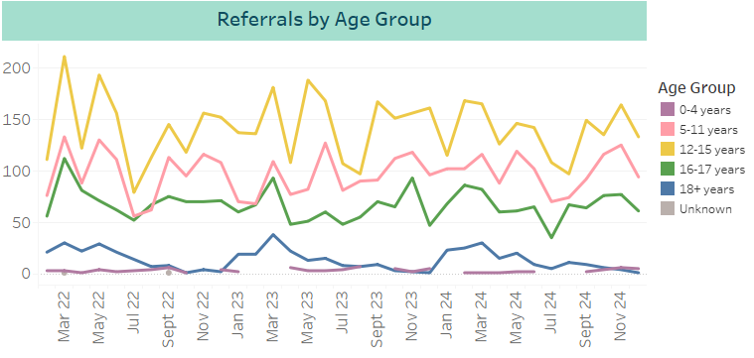
Figure 43: CAMHS Referrals by Age Group

School surveys

Scottish Schools Health and Wellbeing Improvement Research Network (SHINE) Pupil Mental Health Survey looks at different aspects of mental health and wellbeing, subjectively. Aberdeen City have completed this survey four times (March & December 2022, December 2023 & November 2024) and Aberdeenshire once in December 2023 (SHINE data reported here). Moray has opted to complete the Health & Wellbeing Census, last completed in 2021/2022.
Subjective wellbeing is a person's evaluation of their own life and circumstances and is often measured through life satisfaction. Low life satisfaction in adolescents has been related to behaviours such as substance use, depression, fighting and delinquency. In contrast, high life satisfaction has been linked to enhanced coping, self-efficacy, self-esteem, positive self-concept and purpose in life as well as involvement in meaningful pro-social activities. The Good Childhood Index asks young people about their happiness with eleven aspects of life including family, friendships, school, appearance, future, life overall. It is important to pay attention to areas where there are lower levels of satisfaction, which may indicate that additional support is required.

Happiness
Learners were asked to rate how happy they are with various aspects of their life. Response options ranged from 0 to 10, where 0 means 'very unhappy', 5 means 'neither happy nor unhappy' and 10 means 'very happy'.
Figures 44 and 45 show pupils across all age groups in Aberdeenshire (2023) consistently reported the lowest levels of happiness in relation to their appearance and school experiences. These concerns become more pronounced as pupil’s progress from primary into secondary education. Notably, girls expressed significantly lower levels of happiness regarding both appearance and school compared to boys (data not presented here).
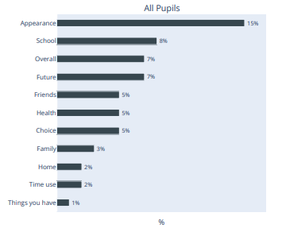
Figure 44: Percentage of Aberdeenshire P6 & P7 who report low happiness in different aspects of life
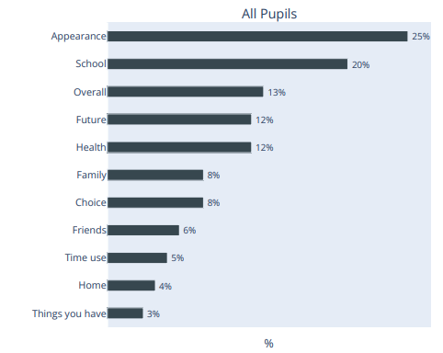
Figure 45: Percentage of Aberdeenshire S1-S6 who report low happiness in different aspects of life
Figure 46 shows that across Aberdeen City P6 and P7, learners were positive about many aspects of their lives and there has been a decrease in the number of learners reporting low happiness in relation to their appearance which is positive. However, across both age groups and gender categories, ‘Appearance’ was still lower than other aspects.

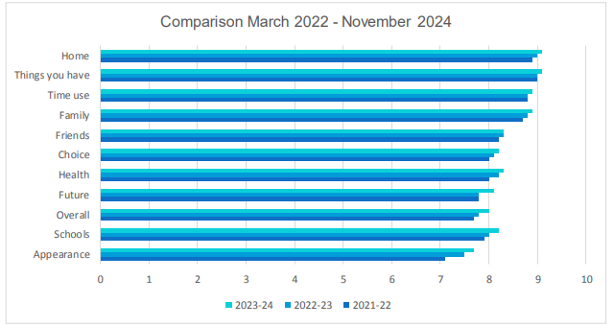
Figure 46: Aberdeen City P6 and P7 who were positive about aspects of their lives

Figure 47 shows that within Aberdeen City Secondary Schools, it was again clear that the aspects of their life learners were most happy with are: home, things they had, time use, friends and family, with school and appearance consistently receiving lower scores.

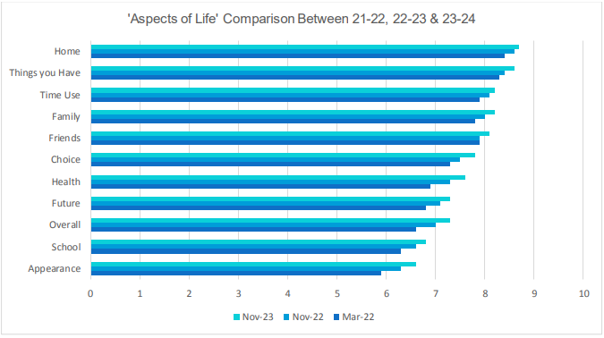
Figure 47: Aberdeen City aspects of life comparison

Figure 48 shows that within Aberdeen City Secondary Schools 2024 data collection, S1-S6 learners again rated the aspects of their lives they were most happy with as: home, things they had, time use, friends and family, with school and appearance rated as areas of low happiness.

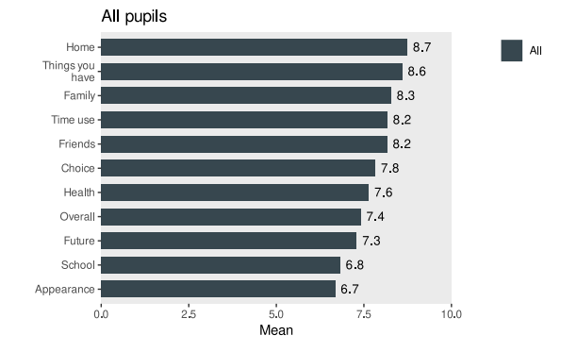
Figure 48: Aberdeen City S1-S6 aspects of life pupils are most happy with aspects of their lives

Low Mood
The WHO–5 Wellbeing Index is a five-item scale which provides a measure of emotional functioning. Answers are summed to create a score ranging from 0 to 100. A score of 50 or less on the WHO-5 indicates low mood, figures 49 and 50 highlight the proportion of those scoring 28 or less and are classified as at risk of depression.

Figure 49 shows that for Aberdeen City, 80% of those in Primary 6 and 7 didn’t show evidence of low mood. This is an increase of 9% since March 2022. As a result, 20%, 712 (25%, 883) learners across Aberdeen P6 and P7 population self-rated below the 50-score threshold, showing a decrease in those reporting low mood. The longitudinal outcome for girls (from P6 in March 2022 to P7 in November 2023) shows an increase in the proportion of learners self-reporting low mood which is an outlier in terms of the outcomes for each of the other cohorts and worthy of further exploration at school and community level.

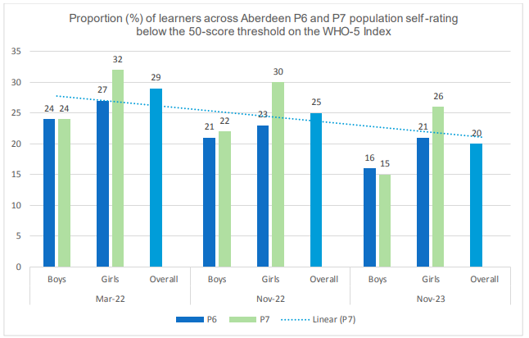
Figure 49: Proportion of learners across Aberdeen City P6 and P7 self-rating the below 50 score threshold on the WHO-5 index

Figure 50 shows the percentage of Aberdeen City Secondary Schools P5-P6 learners, 2024 data collection, who reported a score of 50 or less on the WHO-5 indicates low mood. The figure also includes the results from the HBSC Scotland national average.

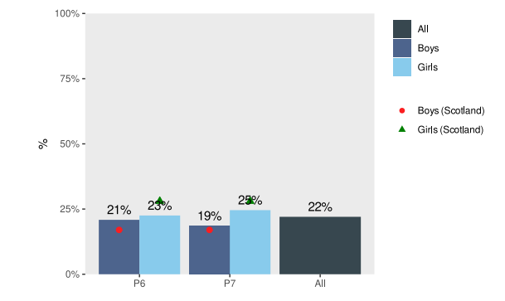
Figure 50: Aberdeen City P6 and P7 who reported score of 50 or less on WHO-5

Figure 51 shows the proportion of Aberdeen City learners across S1-S6 self-rating below the 50-score threshold on the WHO Wellbeing Index is showing continued signs of improvement across each phase, and for all learners in this cohort (2022 – 2023).
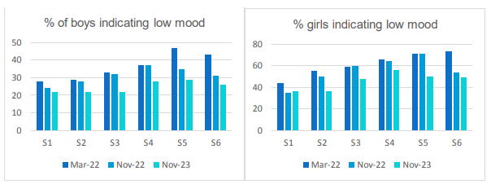
Figure 51: Aberdeen City S1-S6 indicating low mood

Figure 52 shows the proportion of Aberdeen City learners across S1-S6 self-rating below the 50-score threshold on the WHO Wellbeing Index for data collected in 2024, girls higher than the Scottish average and boys slightly higher in S1 & S2 than the Scottish average.

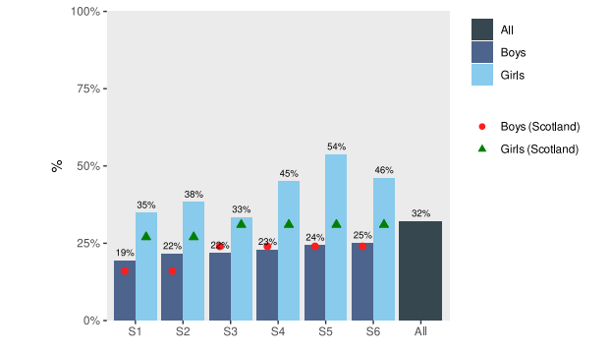
Figure 52: Aberdeen City S1-S6 self-rating below 50 threshold on WHO Wellbeing Index

Risk of Depression
Figure 53 highlights the proportion of Aberdeen City S1-S6 learners scoring 28 or less and are classified as at risk of depression. We see a reduction in the number of learners at risk of depression in both gender groups and every year group, apart from S1 girls where there was a drop in Nov 2022 but this has increased again in 2023.

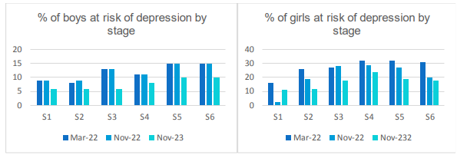
Figure 53: Aberdeen City S1-S6 at risk of depression

Figure 54 highlights the proportion of Aberdeen City S1-S6 learners scoring 28 or less and are classified as at risk of depression in 2024. Across all year groups, girls are at higher risk than boys, but are lower than the Scottish average.
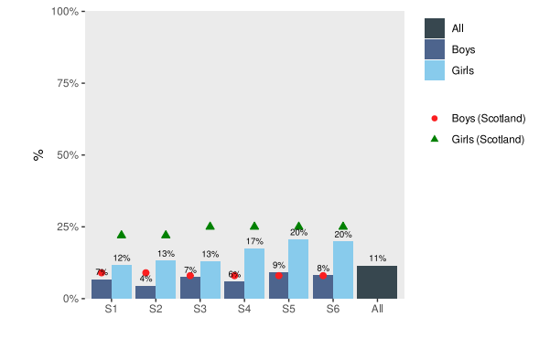
Figure 54: Aberdeen City S1-S6 at risk of depression by sex and stage

Figure 55 shows the percentage Aberdeenshire learners in S1-S6 (2023) scoring 28 or less and classified as at risk of depression compared to the Scottish average provided by SHINE. Although girls are reporting below the Scottish average, boys from S3-S6 are at slightly higher risk levels of depression compared to the Scottish average.

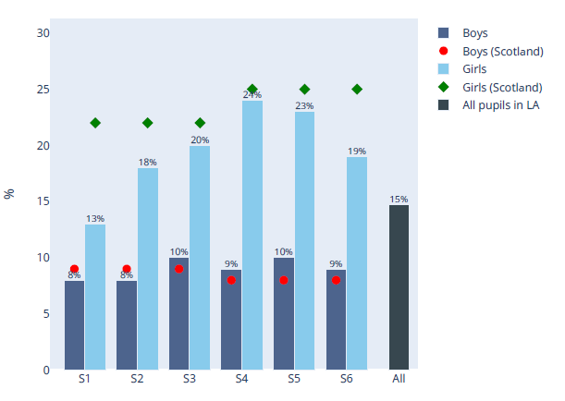
Figure 55: Aberdeenshire S1-S6 at risk of depression by sex and stage

Strength and difficulties
The Strength and Difficulties Questionnaire measures mental health difficulties in different areas: emotional symptoms, conduct, hyperactivity and peer relationships. In each area, the answers to questions are scored and pupils classified into groups, according to pre-determined cut-offs: as expected, borderline and difficulties.

Figure 56 shows the outcomes of the Strength and Difficulties Questionnaire over three collection points for Aberdeen City S1-S6 learners. Reviewing all year groups (data not presented here) there is still a very clear, higher percentage of girls showing difficulties with hyperactivity and emotions.
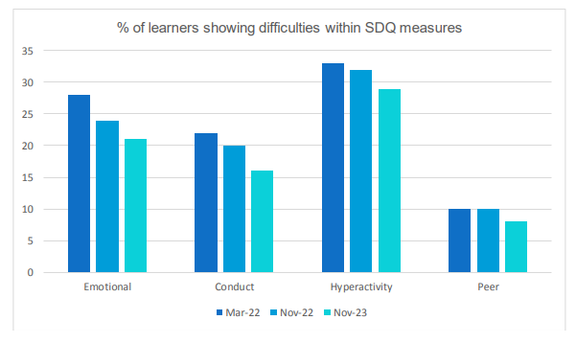
Figure 56: Percentage of learners showing difficulties within SDQ measures

Figure 57 shows the outcomes of the Strength and Difficulties Questionnaire for Aberdeen City S1-S6 learners in 2024 data collection. Again it was reported that a higher percentage of girls reported difficulties with hyperactivity and emotions (data not presented here).

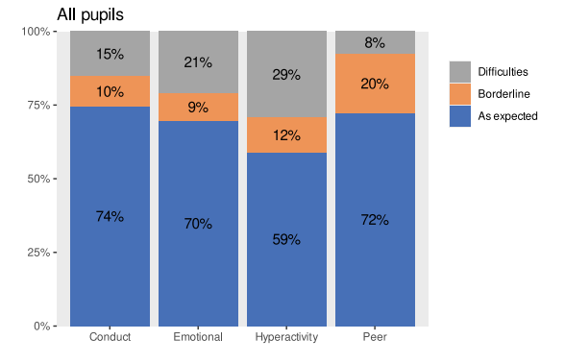
Figure 57: Aberdeen City S1-S6 Strength and Difficulties Questionnaire Results

Figure 58 shows the outcomes of the Strength and Difficulties Questionnaire for Aberdeenshire S1-S6 learners (2023). Reviewing the data across all years, there is a higher percentage of girls showing difficulties with hyperactivity and emotions.
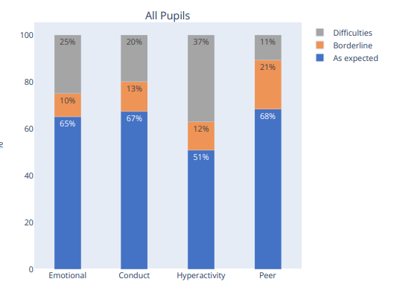
Figure 58: Aberdeenshire S1-S6 Strength and Difficulties Questionnaire Results

Loneliness
There are links between high loneliness, other areas of wellbeing and decreasing positive life outcomes. Research on loneliness in teenagers tells us that teenagers report higher levels of loneliness than any other age group in society. Additionally, self-reports of feelings of loneliness are related to their need to feel socially connected, particularly to groups. Even a short time away from a strong positive group can make them feel lonely. Many secondary school's activities and clubs, outdoors sporting clubs to a lesser extent, were suspended in line with the range of restrictions from the Covid-19 pandemic. Pupils were asked how often they felt lonely during the past week.

Figure 59 shows 25% (2022) of Aberdeen City (S1-S6) learners stated that they felt lonely most or all the time, with a slight decrease at the second collection point to 21%.

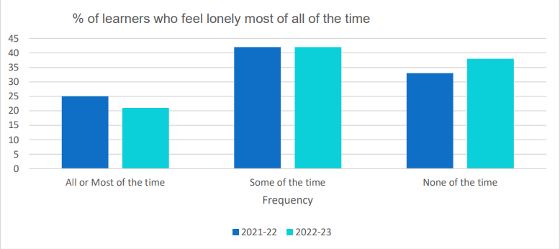
Figure 59: Percentage of Aberdeen City learners who feel lonely most of all of the time

Figure 60 shows data collection point in the autumn of 2024, Aberdeen City (S1-S6) learners reporting that they felt lonely all or most of the time, overall there has been a decrease from 21% to 17%.

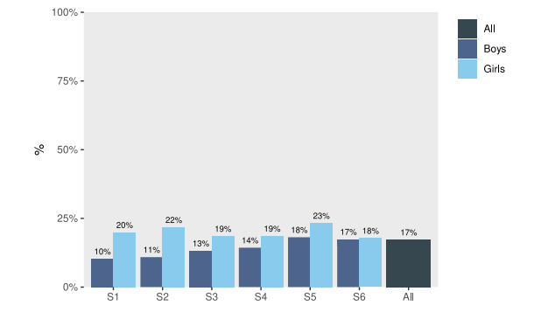
Figure 60: Aberdeen City S1-S6 reporting they felt lonely all or most of the time

Figure 61 shows the percentage of Aberdeenshire S1-S6 learners (2023) who reported that they felt lonely all or most of the time. Across all year groups there is a higher percentage of girls, particularly in years S1 – S4, who report feeling lonely all or most of the time.
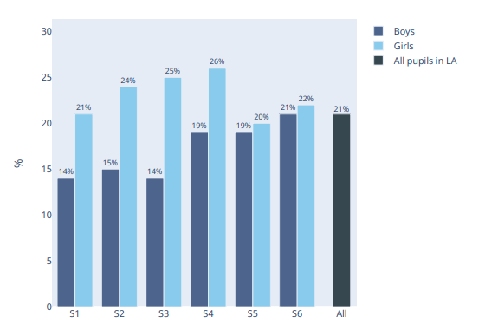
Figure 61: Percentage of Aberdeenshire S1-S6 reporting they felt lonely all or most of the time

Self-Harm
It is difficult to find accurate data on the prevalence of self-harm amongst adolescents, but lifetime self-harm is estimated to be between 10-20%
Figure 62 shows that the percentage of Aberdeen City S1-S6 learners reporting whether they have ever hurt themselves on purpose has decreased from data collection in 2022 to 2023. Although not presented here, there is a noticeable difference between the responses from girls and boys with a larger percentage of girls reporting ‘yes or prefer not to say’ than boys. This gender difference is seen nationally, and for all ages of the Scottish Population.
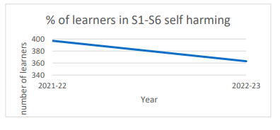
Figure 62: Percentage of learners in S1-S6 self-harming in Aberdeen City

Figure 63 presents the percentage of Aberdeen City S1 – S6 learners who have ever hurt themselves on purpose in the 2024 data collection. Again we can see a higher percentage of girls reporting ‘yes or prefer not to say’ than boys.
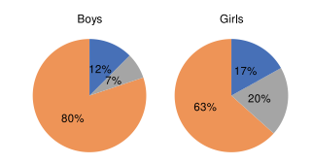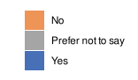
Figure 63: Percentage of Aberdeen City S1-S6 who have ever hurt themselves on purpose

Figure 64 shows the percentage of Aberdeenshire S1-S6 learners who have ever hurt themselves on purpose (2023). Again, we can see a higher percentage of girls reporting ‘yes or prefer not to say’ than boys.

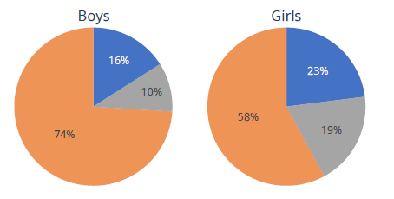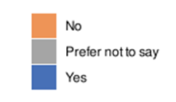
Figure 64: Percentage of Aberdeenshire S1-S6 who have ever hurt themselves on purpose

Developmental concerns
Figure 65 uses a purple line to show the percentage of children who are recorded as having 1 or more developmental concern since 2019. The dashed line highlights the pre-pandemic average of 3.87% of children having at least one developmental, with a blurred line showing where there are 5 or more consecutively increasing or decreasing points. From 2021 onwards, there has been a sustained upward trend in the number of children with more than one developmental concern, with percentages exceeding 10% since 2022. This peaked at 15% in Q3 2024, with current levels at 13% of children.
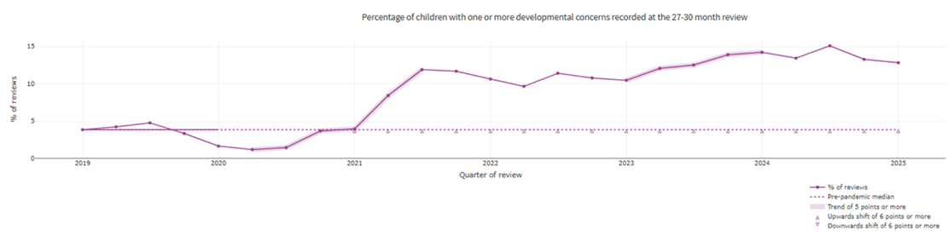

Figure 65: Percentage of children with 1 or more developmental concerns recorded at the 27-30 month review in Grampian

Figure 66 shows that whilst some progress has been made in narrowing the gap between the most deprived and least deprived groups of primary age children, particularly in listening and talking which decreased from 15 percentage points in 2016/17 to 12 in 2022/23, other areas remain unequal. Literacy and numeracy saw a spike in the gap during the covid-19 pandemic year of 2020/21, rising to 25 and 21 percentage points respectively, before returning to pre-pandemic levels.

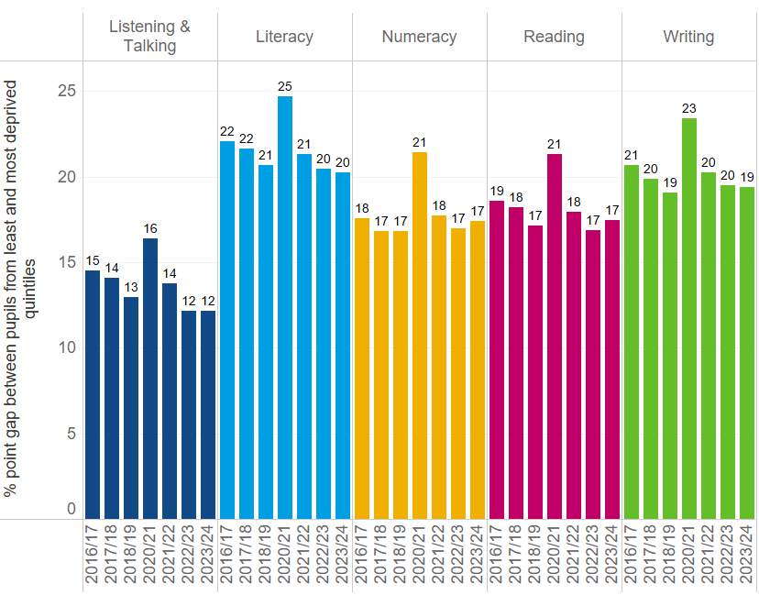

Figure 66: Percentage point gap between primary pupils from the least and most deprived quintiles of the Achievement of Curriculum for Excellence (CfE) levels
Reading and writing also reflect a similar pattern, with gaps widening during the pandemic and only partially recovering in recent years. These trends highlight the enduring impact of socioeconomic disadvantage on educational outcomes and the need for sustained, targeted efforts to close the attainment gap.

References

- Life Expectancy in Scotland 2021-2023 - National Records of Scotland (NRS)
- 5-year Health Equity Plan (2024-29)
- Healthy Life Expectancy, 2021-2023 - National Records of Scotland (NRS)
- Scottish Burden of Disease Forecasting Briefing
- https://www.scotpho.org.uk/media/2631/2025-03-18-scottishburdenofdisease-chronicliverdisease.pdf
- ScotPHO Profiles for NHS Grampian
- SHINE
- The World Health Organization-Five Well-Being Index (WHO-5
- The strengths and difficulties questionnaire (SDQ) : Mentally Healthy Schools
- Prevalence and Characteristics of Self-Harm in Adolescents: Meta-Analyses of Community-Based Studies 1990-2015 https://pubmed.ncbi.nlm.nih.gov/30274648/
- Health in the Early Years in Scotland
- National Improvement Framework Attainment and Health and Wellbeing Measures, 2024

(Life Expectancy in Scotland 2021-2023 - National Records of Scotland (NRS)
5-year Health Equity Plan (2024-29)
Healthy Life Expectancy, 2021-2023 - National Records of Scotland (NRS)
Scottish Burden of Disease Forecasting Briefing
https://www.scotpho.org.uk/media/2631/2025-03-18-scottishburdenofdisease-chronicliverdisease.pdf
ScotPHO Profiles for NHS Grampian
Schools Health and Wellbeing Improvement Research Network SHINE
The World Health Organization-Five Well-Being Index (WHO-5)
The strengths and difficulties questionnaire (SDQ) : Mentally Healthy Schools
https://pubmed.ncbi.nlm.nih.gov/30274648/)
Health in the Early Years in Scotland
National Improvement Framework Attainment and Health and Wellbeing Measures, 2024

