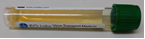
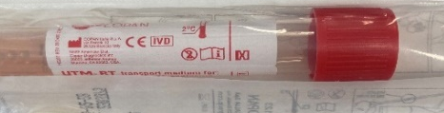
Testing Information Grampian Care Home Residents
Where to access PCR swabs for residents
*Please only use red or green top PCR swabs*
Local Authority Area | Where to access swabs | Who to contact | Where to take completed swabs
Aberdeen City | Aberdeen Community Health and Care Village Mon- Friday 8am-6pm  Aberdeen Community Care and Health Village-Out of hours  50 Frederick Street ,Aberdeen  AB24 5HY | 01224 559140 (Option 2) or gram.citycomrefline@nhs.scot  01224 655510 or  gram.oohnursing@nhs.scot | Monday-Friday : Relevant GP Practice  *Samples taken over the weekend or evenings, keep until the next working day and drop at GP practice.  Alternatively, samples can be dropped off at ARI labs reception, which is located in the south block, level 2.
Aberdeenshire | Collect from local hospital  All times  Banff Chalmers Hospital  Fraserburgh Hospital  Peterhead Hospital –MIU  Turriff Hospital  Inverurie Hospital  Aboyne Hospital  Banchory Glen O’Dee  Huntly Hospital MIU  Kincardine Hospital | 01261 819127  01346 513151/585120  01779 478234  01888 563293  01467 672735 (Donbank ward)  01339 886433  01330 822233  0345 456 6000 01466 765016 (MIU)  01569 765150 | Monday-Friday : Relevant GP Practice  *Samples taken over the evenings or weekends, keep until the next working day and drop at GP practice/community hospital.  Any issues out of hours, care home should call partnership duty manager via NHSG operator 03454566000
Moray | The Oaks, Elgin  Buckie Hospital  Dufftown hospital | 01343 562450  01542 832081  01340 820215 | Monday-Friday : Relevant GP Practice  *Samples taken over the weekend or evenings, keep until the next working day and drop at GP practice.
*Red top PCR swabs- order number 119314, minimum order is 50 and costs £103

