Transmission Based Precautions (TBPs)
The updated Transmission-Based Precautions (TBP) guidance has now been published within the Care Home Infection Prevention and Control Manual (CHIPCM).
The guidance reflects the latest evidence and introduces updated terminology. The terms 'droplet' and 'airborne' transmission are no longer used and have been replaced with 'Contact Transmission' and 'Air Transmission'. This change supports a more risk-based approach to assessing and managing infection risks in care home settings.
To support implementation, the following resources are now available:
- What's Changed Guide – provides an overview of the key changes within the CHIPCM and includes links to the relevant sections.
- Frequently Asked Questions (FAQs) – answers common questions about the updated guidance.
- Updated TURAS Learn modules – including a new Transmission-Based Precautions module and updates to the Patient/Resident Placement and Assessment for Infection module.
- Powerpoint slideset – recorded webinar explaining the changes
What does this mean for you?
The main change is that the guidance helps you choose the right level of respiratory protection based on the infection and level of risk.
These have been categorised into R1, R2, and R3. Appendix 11 explains which category the infection falls into and what respiratory protection is required.
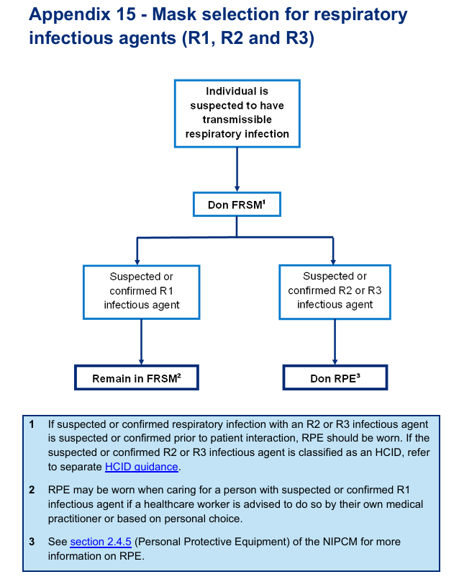
Example- resident has respiratory symptoms-what mask do I wear?
Residents with new respiratory symptoms but no infection has been confirmed yet- Wear a fluid-resistant surgical mask (FRSM) while providing care. Respiratory Symptoms Screening

Infection is suspected or confirmed?
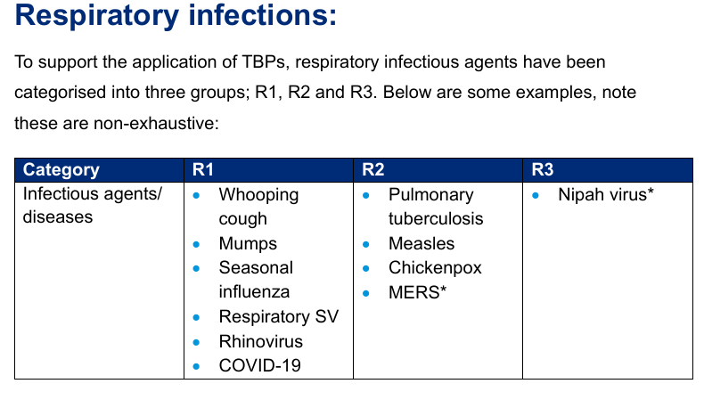
Check the TBP guidance- appendix 11 to see whether the infection is R1, R2, or R3.
Remember
Mask should be worn before entering the resident’s room or care area.
Not sure? Don’t guess, check the guidance or call HPT

