Frequently asked questions (FAQ): Gastrointestinal (GI) illness in care homes.

1: Identifying SYMPTOMATIC RESIDENTS and staff
What is the definition of a symptomatic resident and/or staff?
A resident or staff member experiencing three or more episodes of loose or liquid stools (similar to Bristol stool chart types 6 &7), which is unusual for them or sudden alteration of bowel pattern, within a 24- hour period, and/or unexplained vomiting.
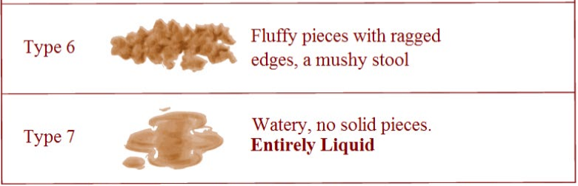
When should I notify the Health Protection Team (HPT)?
Promptly notify HPT, when there are two or more residents and/or staff with similar symptoms or confirmed cases.
How long should symptomatic residents be isolated?
Isolate residents for 48 hours after their symptoms stop and they feel well.
A staff member has reported symptoms of Diarrhoea and or vomiting, when can they return to work?
Staff member can return to the setting 48 hours after their symptoms stop and they feel well enough to return to normal activities.

2: cOLLECTING and sending stool samples
Where can I get a stool sample pot?
Sample pots are available from your care assurance team or GP practices. If you have issues accessing sample pots please contact the HPT.

What should I write on the request form?
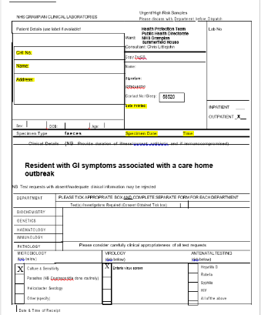
Please use the HPT pre-populated request form, if you don’t have one contact HPT.
- Print out form
- Fill out details for all highlighted areas before sending. If this is not completed the laboratory will not analyse the sample.
- Fold form and put it into the front pouch of the clear specimen bag with “Micro-biology” facing out with.
- Put sample pot into the sealed pouch.

Do I need to write on the sample pot?
Yes. Write on both the sample pot and the request form. Please fill out all details requested on the sample, see example below. Unlabelled samples will be rejected by the laboratory.
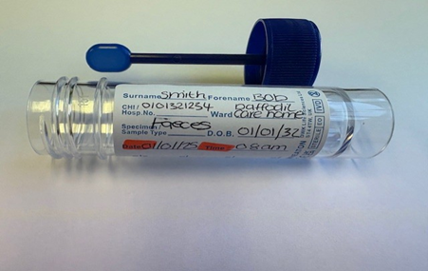
How many stool sample pots do I send?
Send one sample pot per symptomatic resident.
Where do I send the stool samples?
Deliver to your GP practice or directly to Aberdeen Royal Infirmary (ARI) laboratory reception, which is located on level 2 in the south block.
I have taken a stool sample but the GP practice is closed and it is now the weekend?
Samples can be dropped off directly at ARI laboratory reception, this is located in the south block, on level 2. For Moray residents, samples can be dropped off at the laboratory located at Dr Grays Hospital. If this is not possible the sample can be stored in a specimen fridge until the next working day or dropped off at any community hospital for collection.

3. Obtaining stool samples
Can I collect a stool sample from soiled clothing and continence pads?
Yes. Samples can be taken from soiled incontinence pads or clothing, even if contaminated with urine.
What is the minimum quantity of stool sample required?
The minimum quantity required is 2mls, larger samples are preferred.

4. Visiting and social events DURING AN OUTBREak
Are communal events allowed during a GI outbreak?
Avoid external entertainment, visits and large gatherings (e.g., nurseries, schools, singers, coffee mornings) until the outbreak has been declared over.
Internal communal activities within resident cohorts can continue for non-isolating residents.
Non-isolating residents can continue to go out with family or friends.
Can symptomatic residents have visitors?
Yes, but inform visitors of the resident’s isolation status beforehand. All visitors are required to follow infection control measures to prevent onward transmission.
- Wash hands with running water and liquid soap before and after visiting.
- Appropriate use of Personal Protective Equipment (PPE) as advised by staff.
- Symptomatic visitors must not attend until they are 48 hours free from their last symptom

Can communal areas remain open in an outbreak?
Yes. Resident’s communal areas should remain open for use by residents who are not identified as cases or symptomatic.
We are currently closed to admissions and discharges, what does this mean?
During an outbreak new admissions to the care setting should be postponed, if the admission is an emergency please contact the HPT for risk assessment and further advice.
Current residents can return to the setting during an outbreak following a risk assessment.
Respite residents should remain in the setting until the outbreak has been declared over. Seek further advice from HPT in the first instance.
If a resident is being admitted to hospital during an outbreak, please inform the hospital ward and ambulance staff of current outbreak.

5. Personal protective equipment (PPE) and infection control measures
Should I wear a Fluid-Resistant Surgical Mask (FRSM) when caring for a resident with diarrhoea and/or vomiting?
This applies only when caring for a symptomatic and or confirmed resident case who is vomiting. FRSM should not be used as a general enhanced precaution across the setting.
A resident has been sick out with their own room. What should I do?
- Remove resident to own room
- Clean everything within a 3-meter radius of the spill, including all furniture
- Dispose of any exposed food in household waste.
- Use a disinfectant with 1000 parts per million of available chlorine.
- Follow the NIPCM regarding management of waste, linen and PPE
Can staff use alcohol-based hand rub (ABHR) /alcohol hand gel during a GI outbreak?
No, ABHR is ineffective against GI pathogens. Wash hands with running water and liquid soap, then pat dry using disposable paper towels.

6. Guidance and resources
Where can I find the latest GI outbreak guidance?

- Infection Prevention and Control Manual for older people and adult care homes (CH IPC Manual)
- National Infection Prevention and Control Manual: Care Home IPC resource for gastro-intestinal illness
- National Infection Prevention and Control Manual: A-Z Pathogens
- National Infection Prevention and Control Manual: Norovirus - key steps to help stop the spread of infection poster

