FrEquently Asked Questions: rESPIRATORY infections

1: Identifying SYMPTOMATIC RESIDENTS and staff
What is the definition of a symptomatic resident?
A resident with new onset of respiratory symptoms in combination with and/or
- A sudden decline in physical or mental ability
- A fever (above 37.8C)
Symptomatic residents should have a PCR test submitted for a full respiratory screen.
When should I notify the Health Protection Team (HPT)?
Notify HPT if there are two or more symptomatic residents or if you have concerns.
How long should symptomatic residents be isolated?
Symptomatic residents should be isolated in their room, if safe to do so. If consent given, a PCR test should be taken. Residents confirmed with Influenza or COVID-19 should isolate for 5 days or if no symptoms day of PCR test, with day 0 being symptom onset date and 48 hours fever free.
What to do if a resident has tested positive for other respiratory illness, such as Enterovirus, RSV, and Adenovirus?
Please contact the HPT for further advice.
What if I am unable to isolate a symptomatic resident?
Some residents may find isolation difficult, please contact the HPT to discuss in the meantime further guidance can be found following the link below.
Guidance for the public health management of acute respiratory infections (ARI) in community, social and residential care settings
I am unable to test a symptomatic resident, what should I do?
Isolate resident and contact HPT for further advice.
A full respiratory screen has returned negative for a symptomatic resident. When can the resident exit isolation?
If no pathogen is confirmed through testing, the resident can exit isolation when:
- They feel well enough to resume ‘normal activities’.
- 48 hours have passed since they last had a fever (37.8 C or above)

2: COLLECTING and sending PCR samples
What should I use to test a symptomatic resident?
A PCR viral throat swab, using either a red or green sample container (see below images), is the preferred diagnostic tool for all respiratory pathogens.
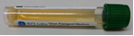
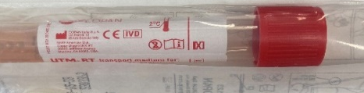

Do I leave the swab inside of the container or remove it for sampling?
Leave the swab inside the container. If removed, the sample will not be analysed
How many PCR samples should we submit?
Current guidance advises submitting samples from up to five symptomatic residents to confirm the pathogen during an outbreak. The HPT may request additional samples and will provide further advice if needed.
Where can I access PCR swabs from?
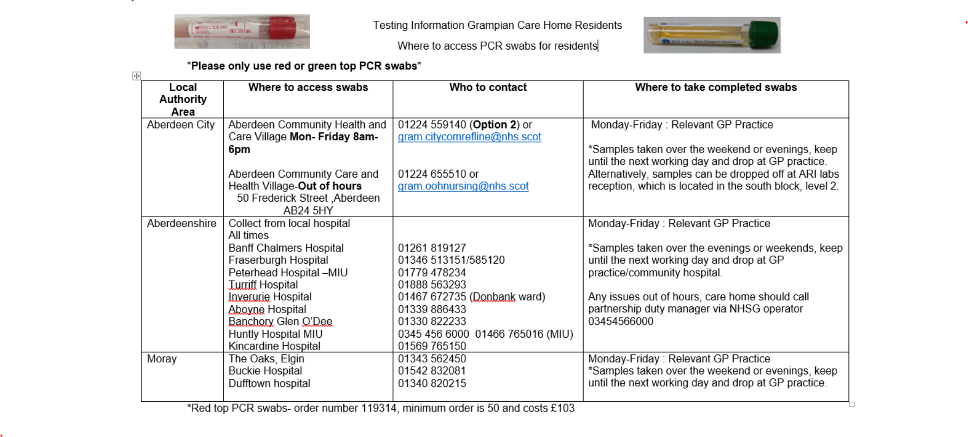
Do symptomatic staff need to be tested?
Staff should not routinely test unless clinically advised by their own GP. Symptomatic staff should follow NHS inform advice. Acute respiratory infection (ARI) | NHS inform
Staff may return to work when they are feeling well and able to resume normal activities. Staff should not have had a high temperature for at least 48 hours and without the use of paracetamol and or ibuprofen. Staff with persistent symptoms such as cough should be risk assessed by their line manager prior to returning to work.
A staff member has tested and positive for Covid-19?
Follow NHS inform advice- Coronavirus (COVID-19) | NHS inform . Staff can return to the setting when
- They are at least 48 hours fever free (if had one) and don’t need medicine to lower the fever.
- Feel well enough to return to ‘normal’ activities
A staff member has come to work wearing a fluid repellent face mask due to cold like symptoms, what should I do?
Symptomatic staff should not attend the setting. Send them home and refer them to the relevant guidance.

3. Visiting and social events DURING AN OUTBREak
Can symptomatic or confirmed residents with respiratory illness have visitors?
The HPT will provide default advice on visiting, including whether open or names visiting initiatives will be implemented. Please consult the HPT regarding visiting guidance.
All residents, whether isolating or not, can continue to have visitors. However, visitors must be informed of the resident’s isolation status beforehand. All visitors are required to follow infection control measures to prevent onward transmission.
- Wash hands with running water and liquid soap before and after visiting.
- Appropriate use of Personal Protective Equipment (PPE) as advised by staff.
- Unwell visitors must not attend until they are 48 hrs free from fever and feel well enough to resume normal activities.

Can communal activities take place during an outbreak for those who are not isolating?
Avoid external entertainment, visits and large gatherings (e.g., nurseries, schools, singers, coffee mornings) until the outbreak has been declared over.
Internal communal activities within resident cohorts can continue for non-isolating residents.
Non-isolating residents can continue to go out with family or friends.
Can communal areas remain open in an outbreak?
Yes. Resident’s communal areas should remain open for use by residents who are not identified as cases or symptomatic.
We are currently closed to admissions and discharges, what does this mean?
New resident admissions- during an outbreak new admissions should be postponed, if the admission is an emergency please contact the HPT for further advice.
Current residents can return to the setting during an outbreak following a risk assessment.
If a resident is being admitted to hospital during an outbreak please inform the hospital ward or ambulance or residential care facility, of current outbreak.

Guidance and resources
Where can I find the latest respiratory guidance?
- National Infection Prevention and Control Manual: Care Home IPC resource for respiratory illness
- Guidance for the public health management of acute respiratory infections (ARI) in community, social and residential care settings
- National Infection Prevention and Control Manual: Winter Preparedness Campaign 2026: See what's changed, share what's new, strengthen your practice!
- Coronavirus (COVID-19) | NHS inform
- Acute respiratory infection (ARI) | NHS inform
- National Infection Prevention and Control Manual: Respiratory Symptoms Screening

